ACCESS THIS DOCUMENT BY SCANNING THIS QR CODE ;

=================================================

<https://docs.google.com/document/d/1Vo9KUuZjJEu3UI86wTAfJ5TOFxGO2VN1B-J8q5Qtruc/edit?usp=sharing>



================================================

1. Chocolatey installation on windows and install below softwares using choco

Notepadplus

Git

VSCODE

VLC

MobaXterm

1. Create and Connect Ec2/VM using AWS Console and Azure Portal.
2. Creating Directories and Files using Vi and Inserting data into files.
3. User,Passwd,Group creation/Deletion in Linux.
4. Copy and move files and folders and directory navigation.
5. Import keys/Ssh keys concept Hands-on .
6. Creating files and directories [FilePermissions ] and changing ownerships.
7. Create 2 users and switch users concept.
8. Create a user and add a user to the group .
9. Practice filter commands in several ways and also practice Linux commands using linux cheat sheets.
10. Create a directory in linux and create 100 files using touch command inside the directory .
11. Create 100 files at a time using a single command.

===========================================

linux.com/what-is-linux/

<http://www.linux-tutorial.info/>

AWS FREE TIER USAGE 👍

—-------------------------------------

[https://aws.amazon.com/free/?all-free-tier.sort-by=item.additionalFields.SortRank&all-free-tier.sort-order=asc&awsf.Free%20Tier%20Types=*all&awsf.Free%20Tier%20Categories=*all](https://aws.amazon.com/free/?all-free-tier.sort-by=item.additionalFields.SortRank&all-free-tier.sort-order=asc&awsf.Free%20Tier%20Types=*all&awsf.Free%20Tier%20Categories=*all)

AWS FREE TIER ACCOUNT CREATION STEP BY STEP :

——————————————————————————-

<https://k21academy.com/amazon-web-services/aws-solutions-architect/create-aws-free-tier-account/>

AZURE FREE TIER ACCOUNT CREATION STEP BY STEP:

———————————————————————————

<https://k21academy.com/microsoft-azure/create-free-microsoft-azure-trial-account/>

Application server/ Database Server / Web Server :

======================================

<https://dev.to/k_penguin_sato/web-serverapplication-serverdatabase-server-d4k>

<https://phoenixnap.com/blog/web-server-vs-application-server>

OSI MODEL :

—----------------

<https://www.geeksforgeeks.org/layers-of-osi-model/>

**Linux commands cheat sheet** :

—----------------------------------------

<https://www.interviewbit.com/linux-commands-cheat-sheet/>

<https://www.guru99.com/linux-commands-cheat-sheet.html>

powercfg/batteryreport

file:///C:/Windows/System32/battery-report.html

Microsoft outlook account creation Steps :

———————————————————-

<https://account.microsoft.com/account?lang=en-hk>

CHOCOLATEY SOFTWARE INSTALLATION:-

—————————————————————

<https://chocolatey.org/install>

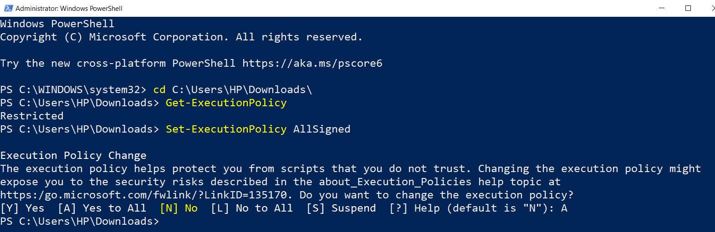

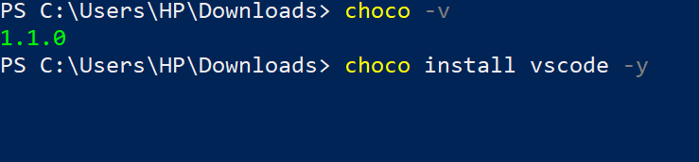

DAY-2 [ Connecting EC2 & VM using SSH ]

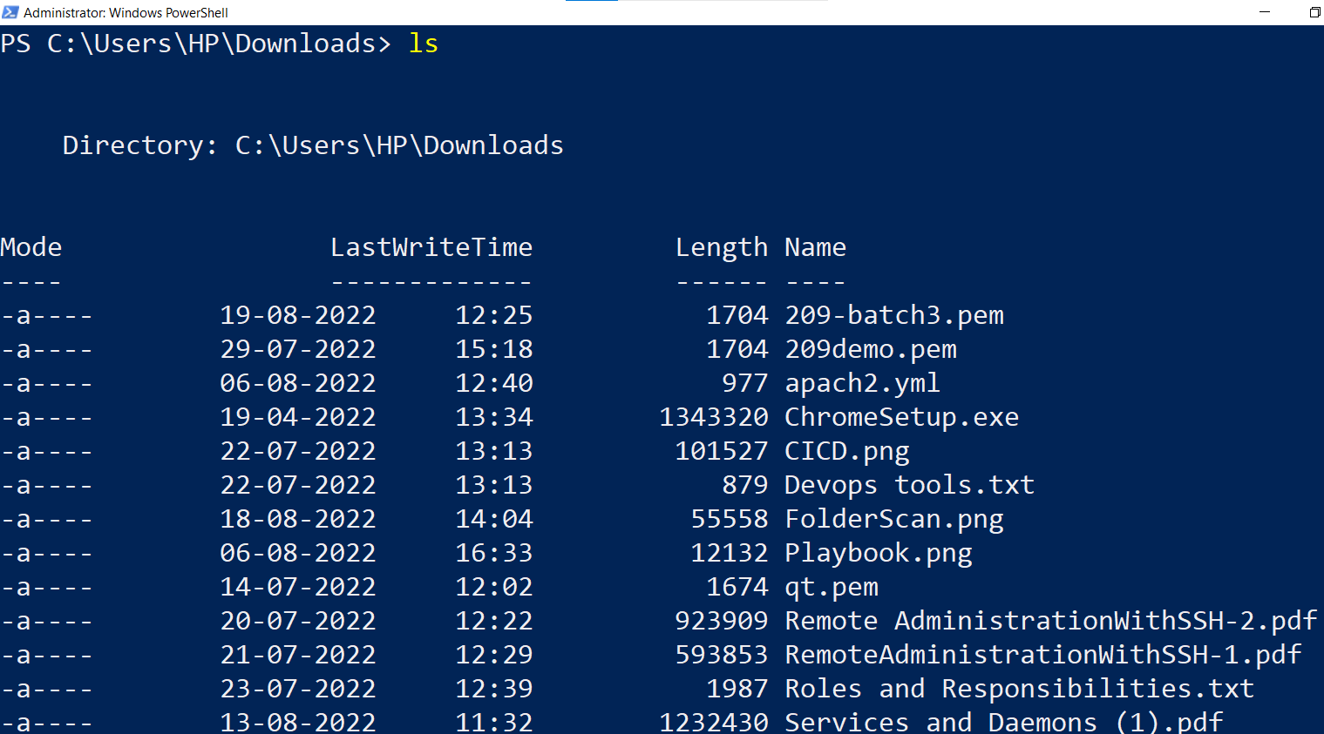

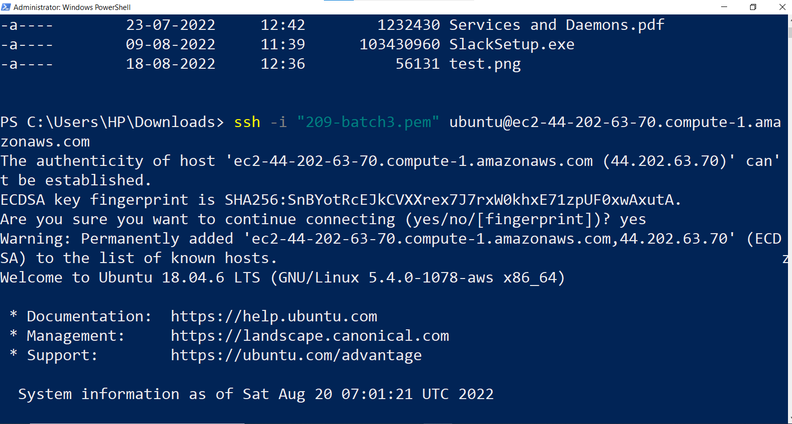

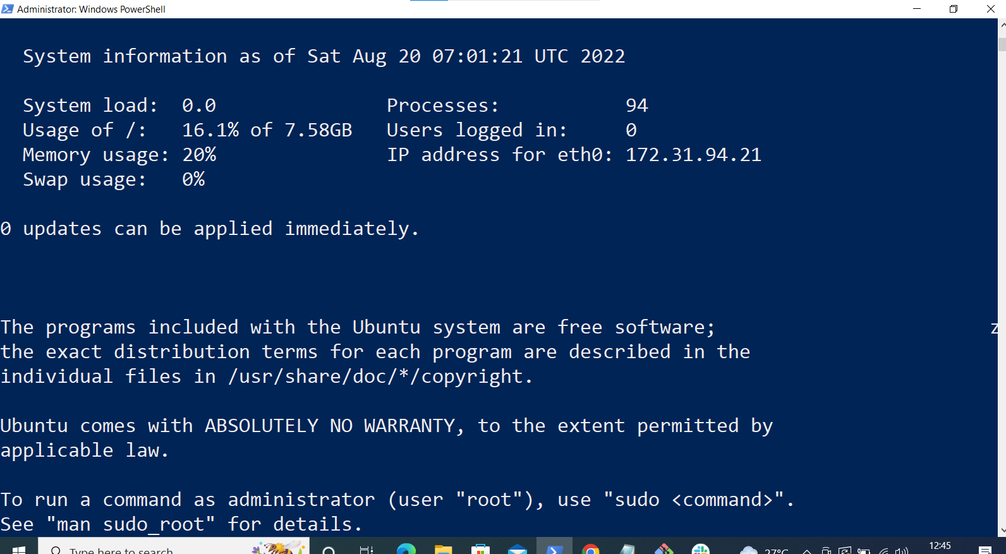

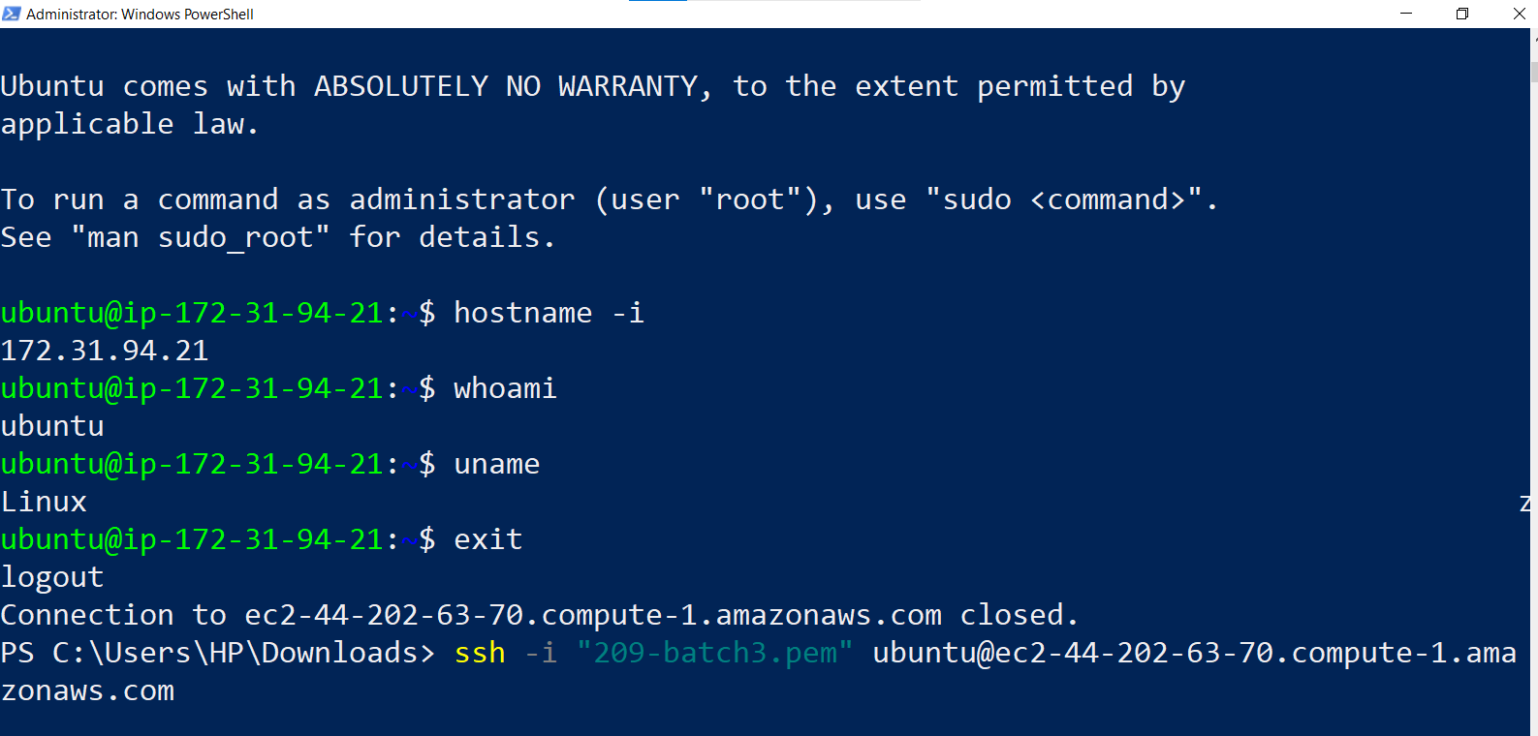

VM Login :

—-----------

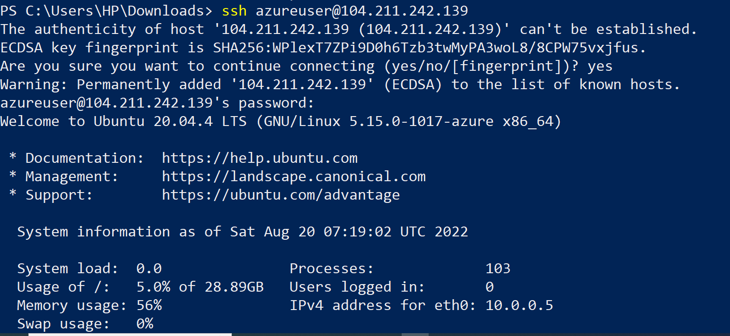

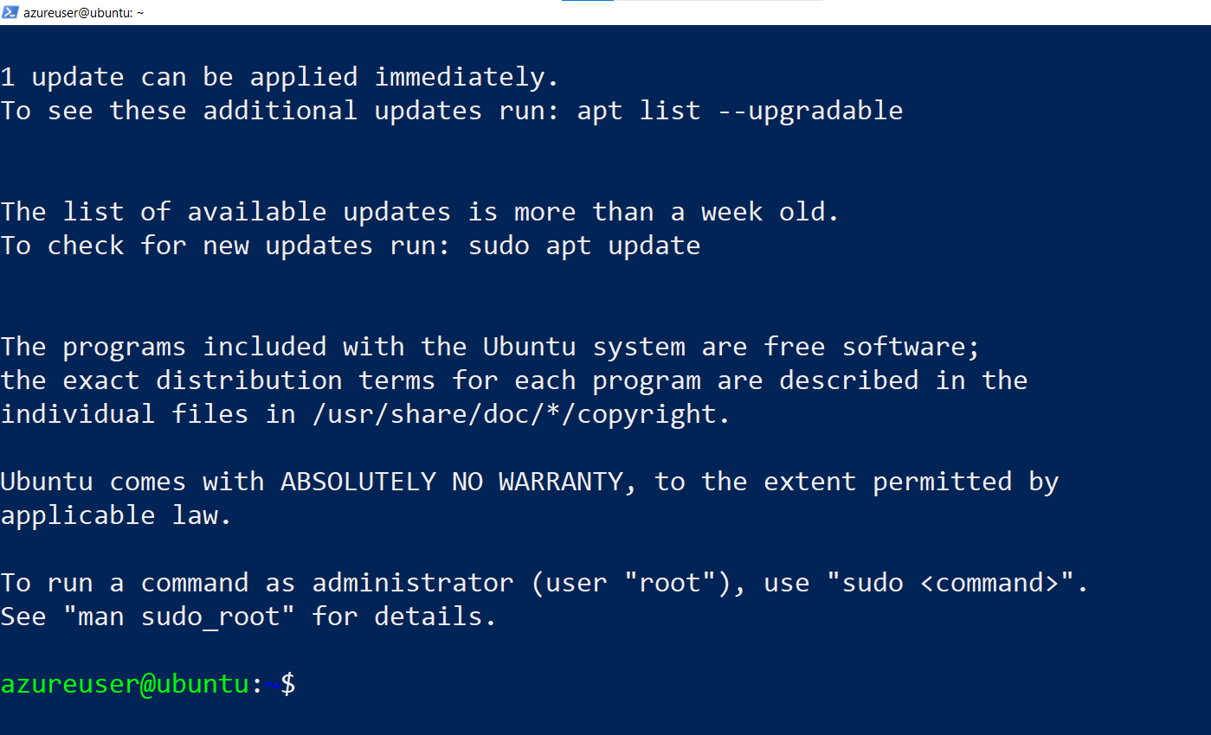

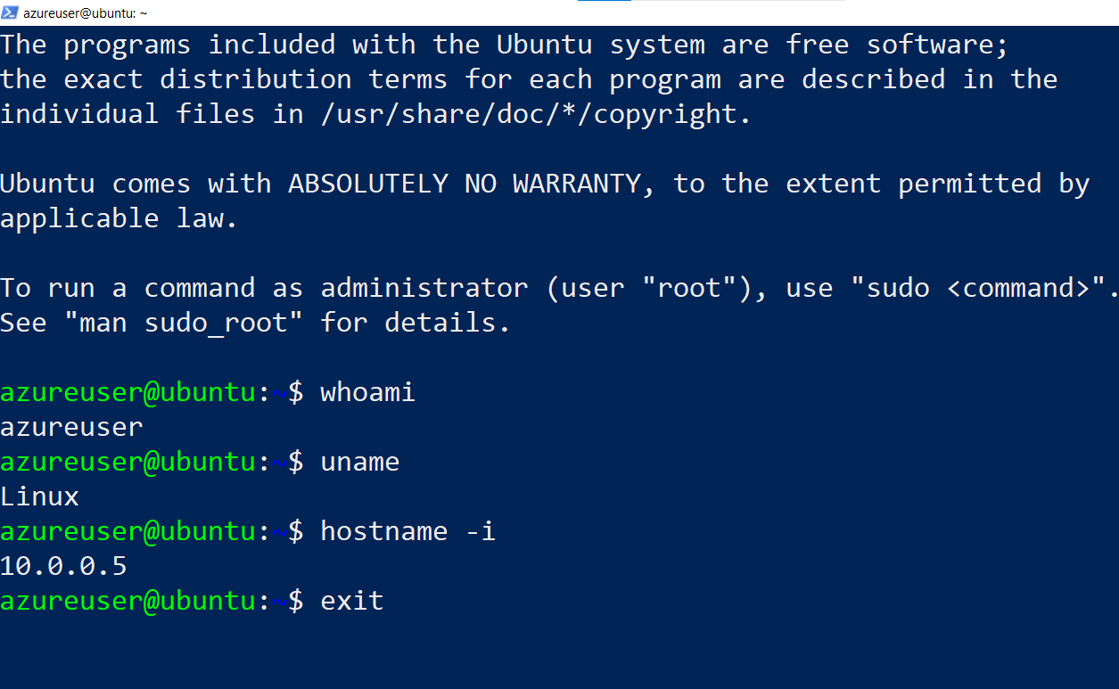

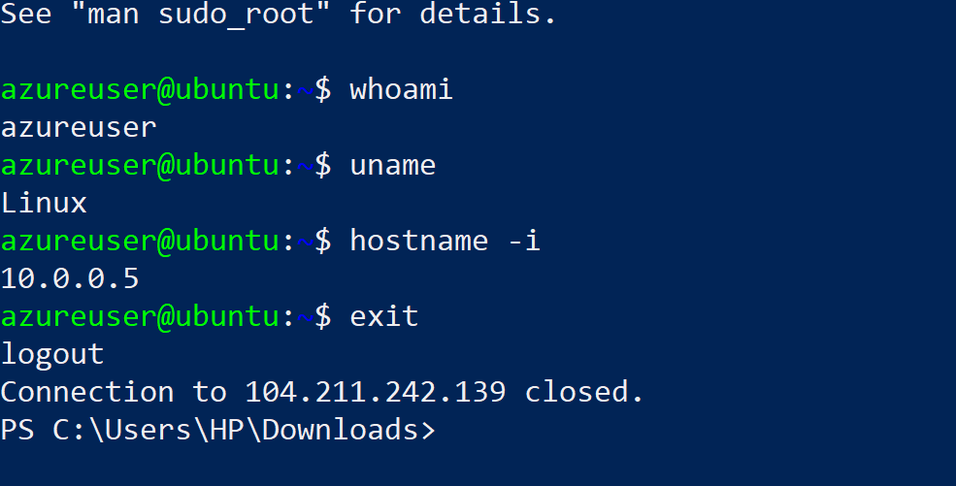

LINUX PRACTICE PLATFORMS

<https://openvim.com/> [ Vi editor practice ]

https://www.tutorialspoint.com/linux_terminal_online.php

https://kinsta.com/blog/linux-commands/

https://labex.io/courses/linux-basic-commands-practice-online

https://www.practicelinux.com/

<https://cocalc.com/features/terminal>

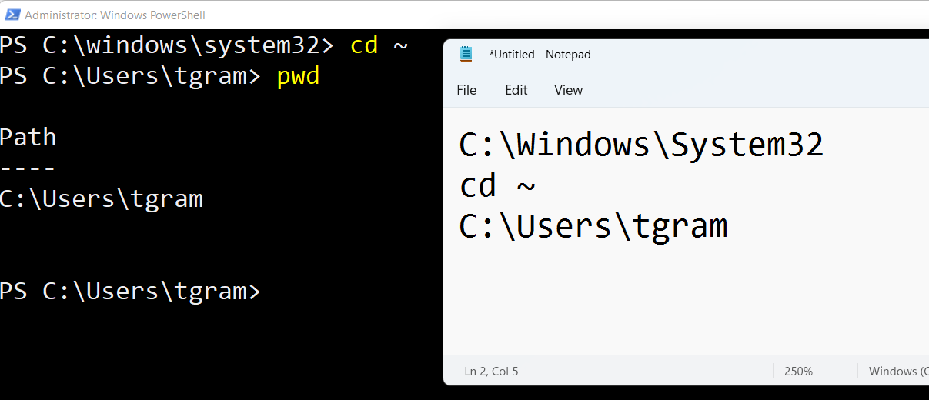

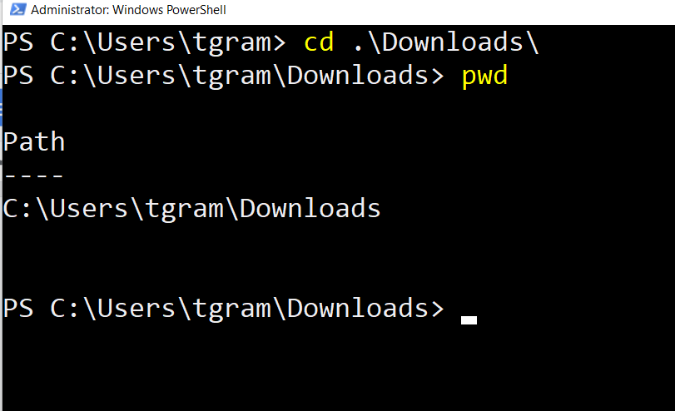

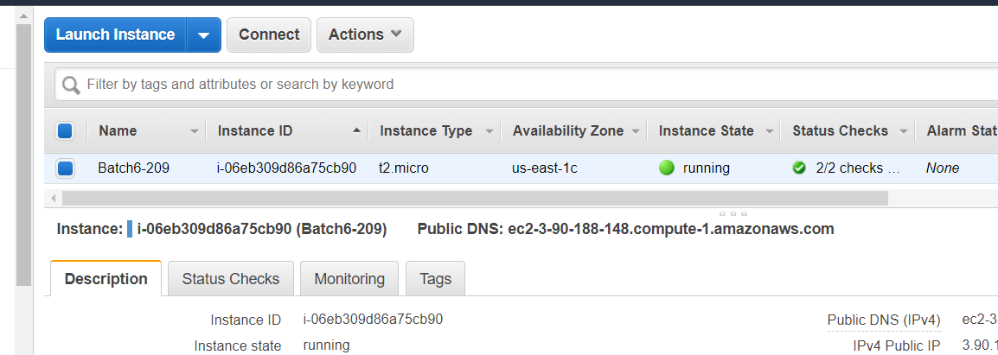

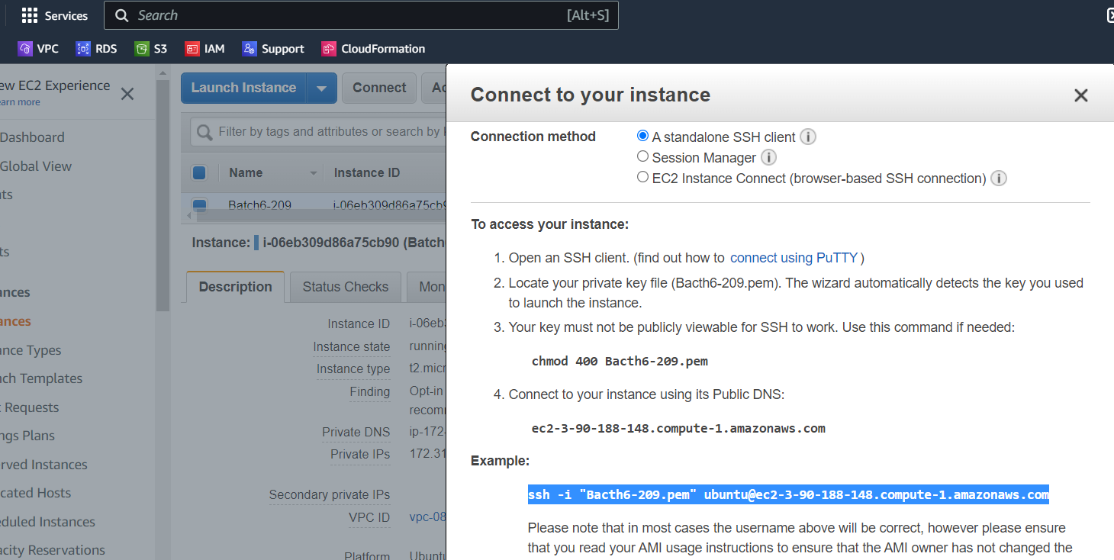

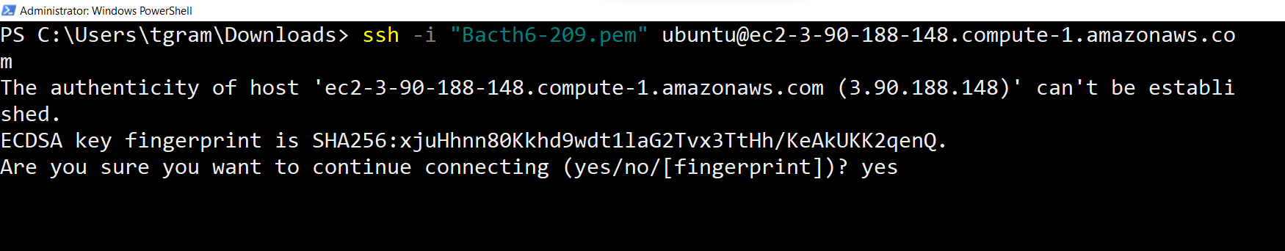

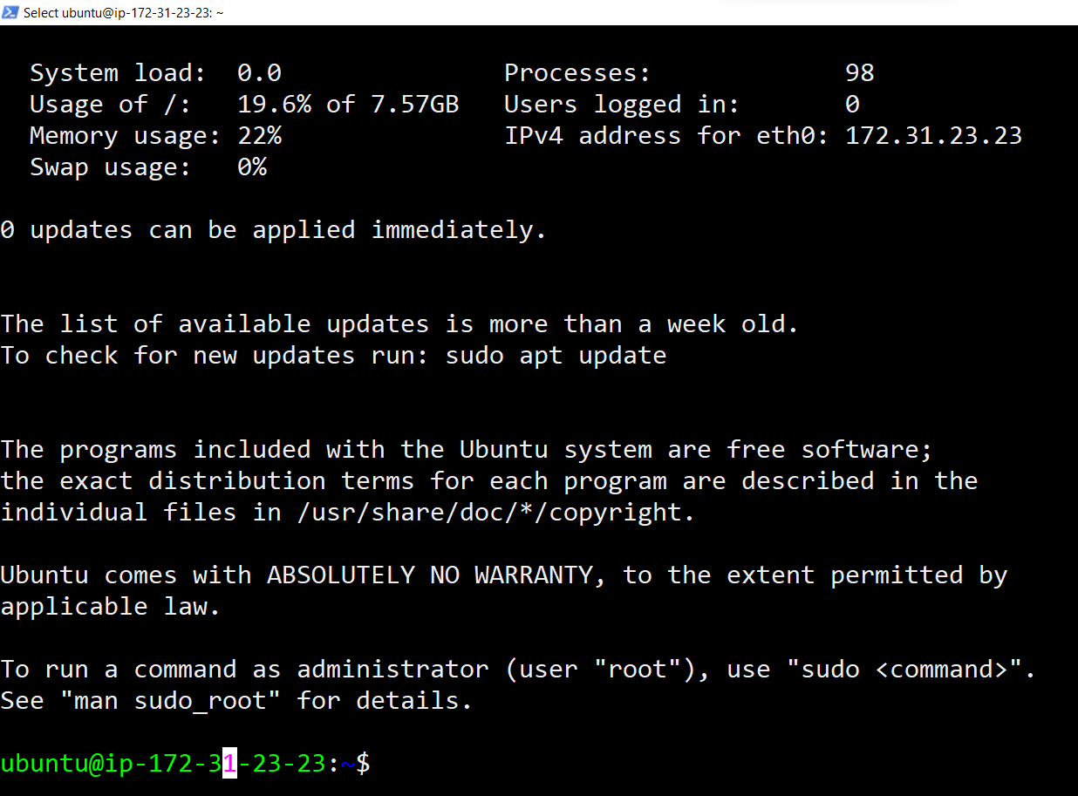

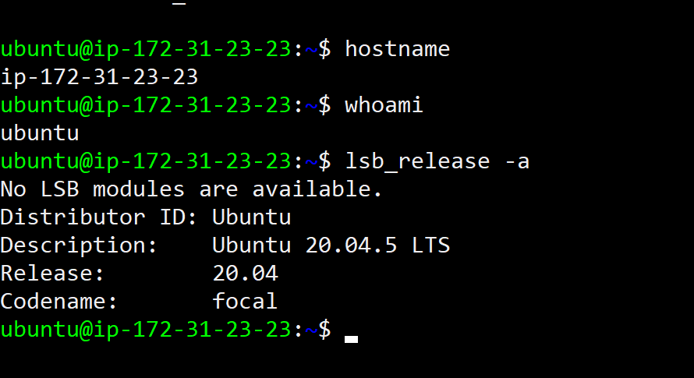

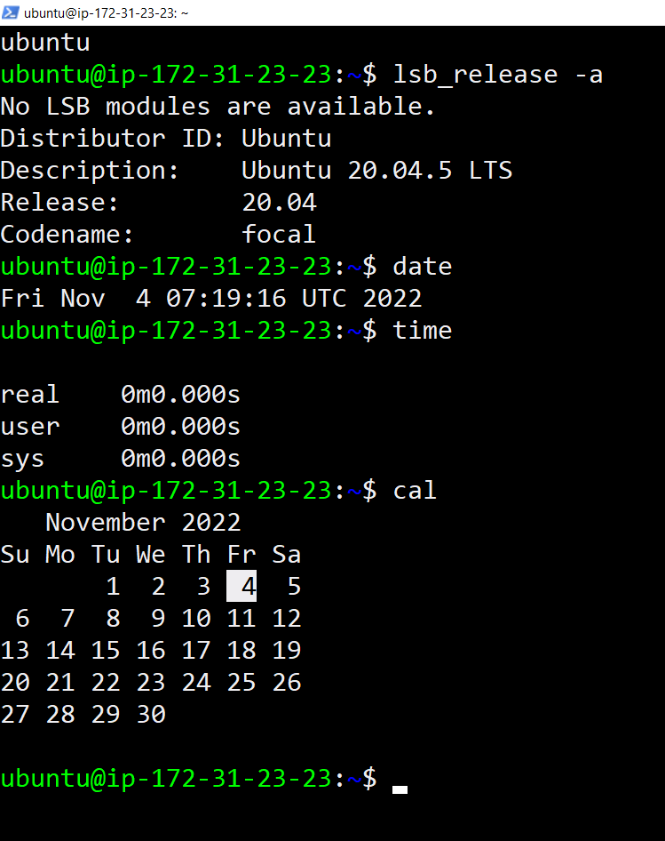

LINUX CHEAT SHEET 👍

======================

<https://www.guru99.com/linux-commands-cheat-sheet.html>

CHOCOLATEY INstallation 👏

—------------------------------------

<https://chocolatey.org/install>

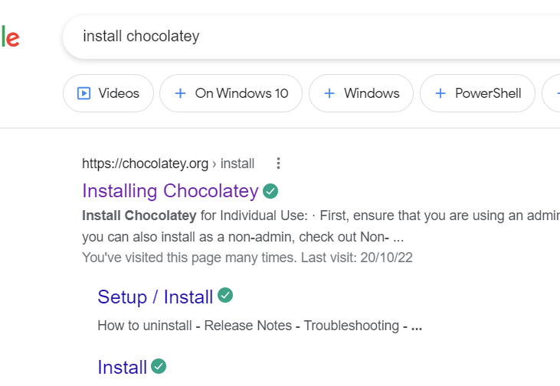

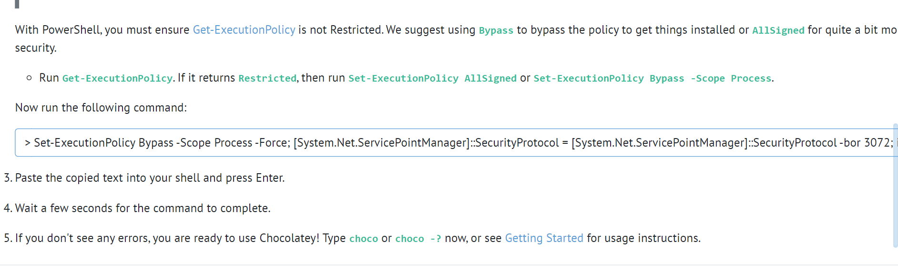

1. [ <https://openvim.com/> ]

1. Install chocolatey software on windows.

2. Install below softwares using chocolatey.

-> Git

-> Vscode [ https://community.chocolatey.org/packages/vscode ]

-> Notepadplusplus [ ]

-> Terraform

-> Vlc

-> Mobaxterm

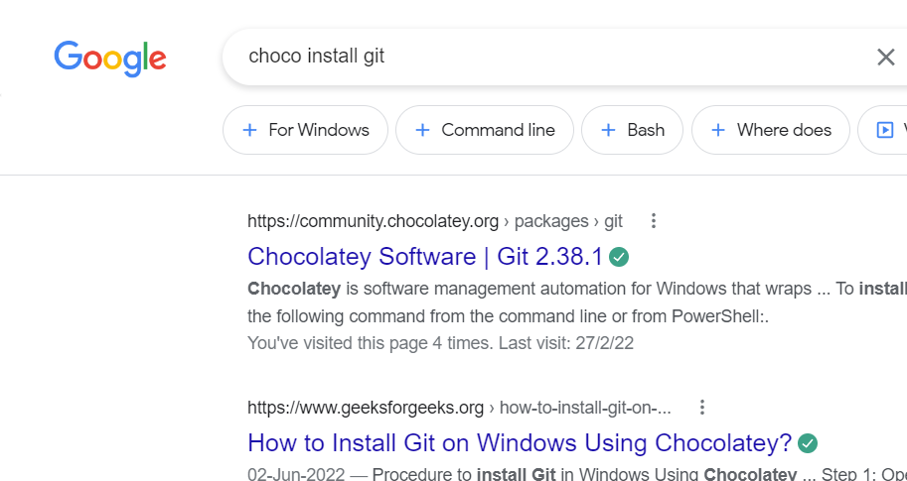

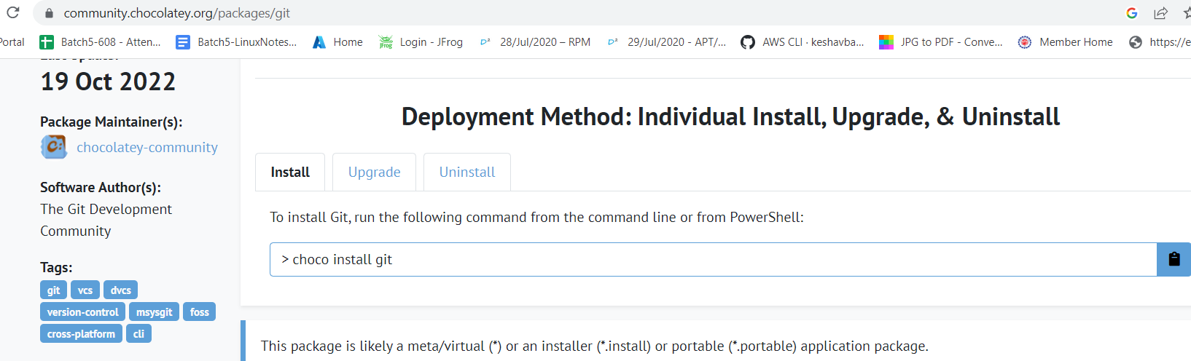

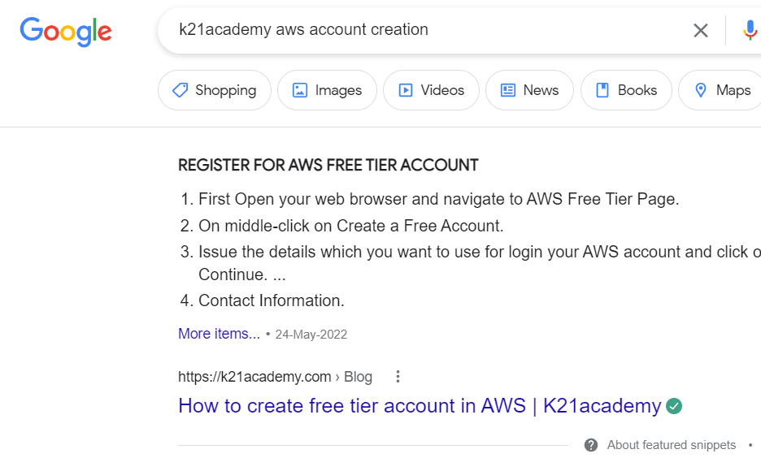

<https://k21academy.com/amazon-web-services/aws-solutions-architect/create-aws-free-tier-account/>

After login into VM 👍

—-----------------------------

ps

ps -aux

Ip addr

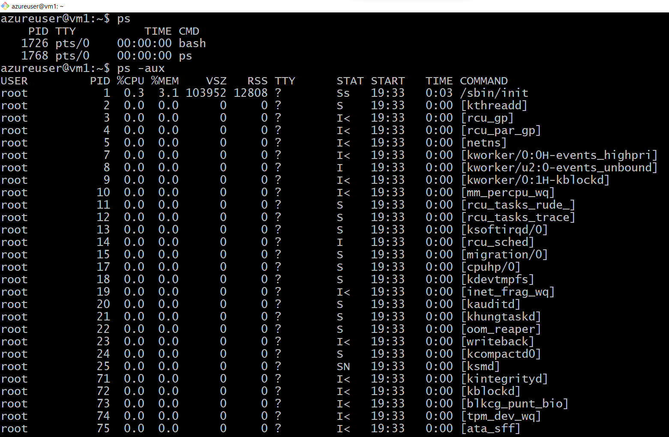

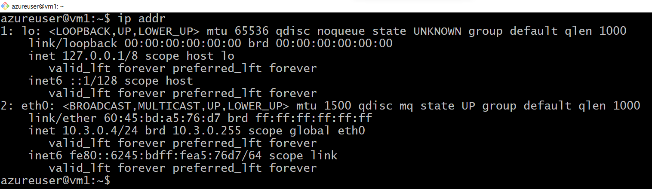

df -h

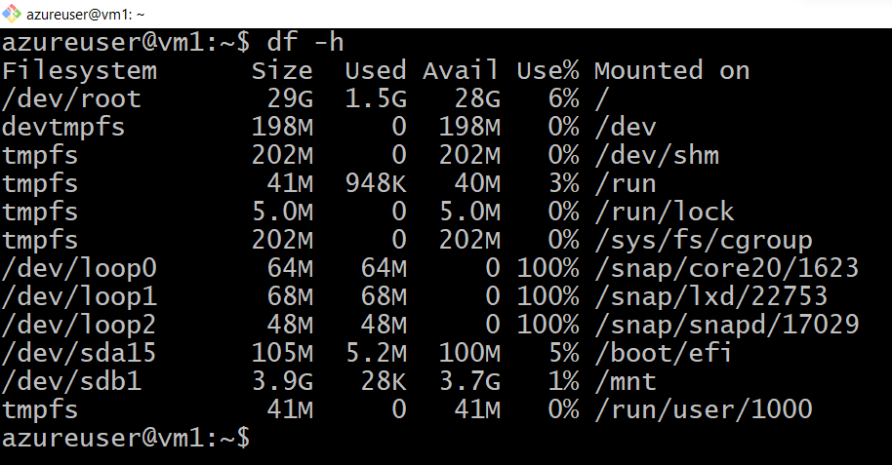

lsblk

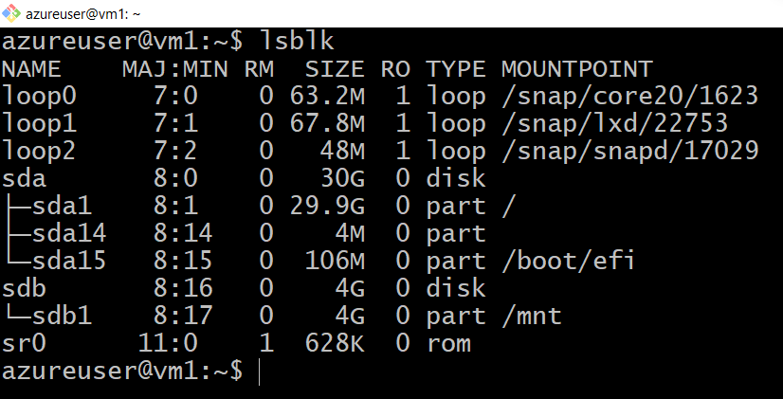

top

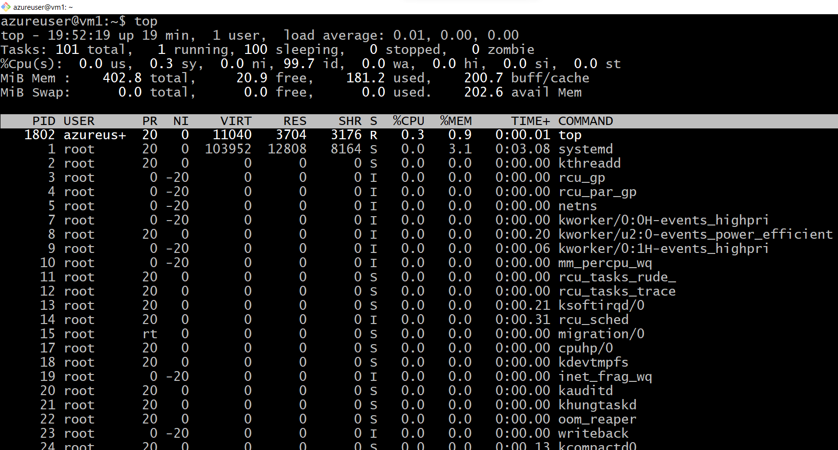

htop

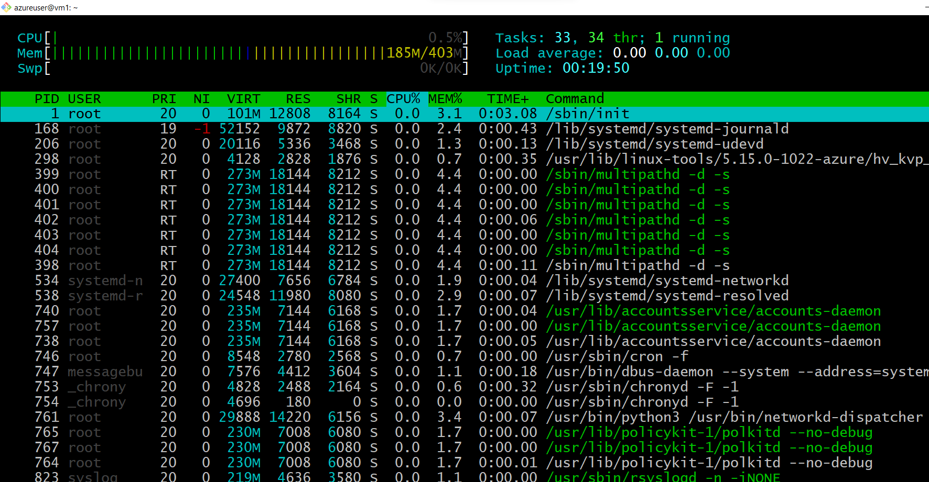

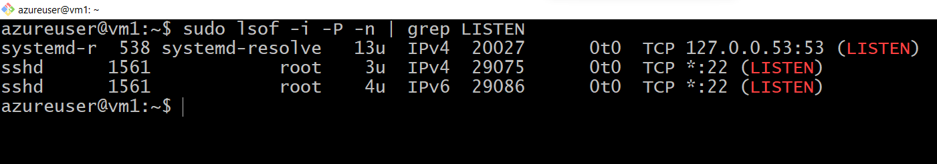

<https://www.cyberciti.biz/faq/unix-linux-check-if-port-is-in-use-command/>

sudo lsof -i -P -n | grep LISTEN

$ sudo netstat -tulpn | grep LISTEN

$ sudo ss -tulpn | grep LISTEN

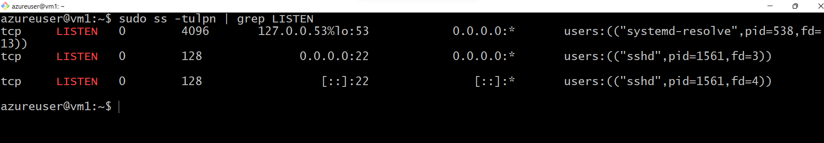

$ sudo lsof -i:22 ## see a specific port such as 22 ##

$ sudo nmap -sTU -O IP-address-Here

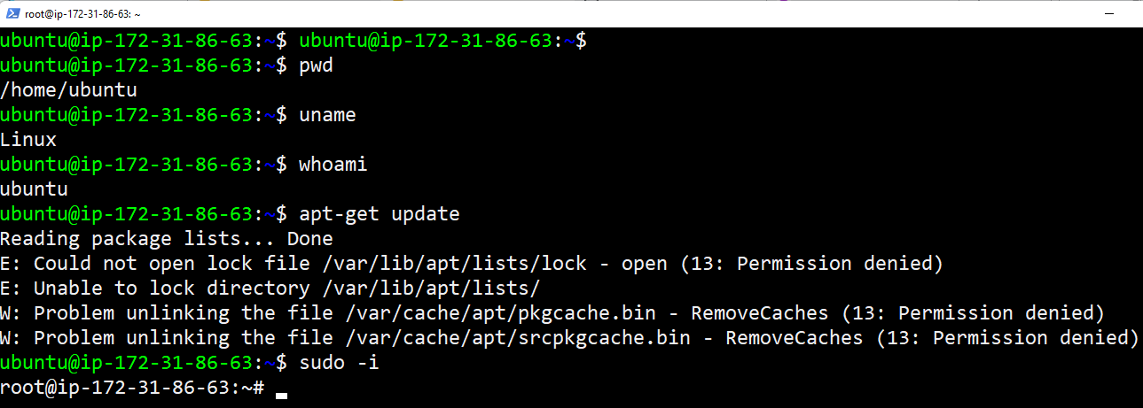

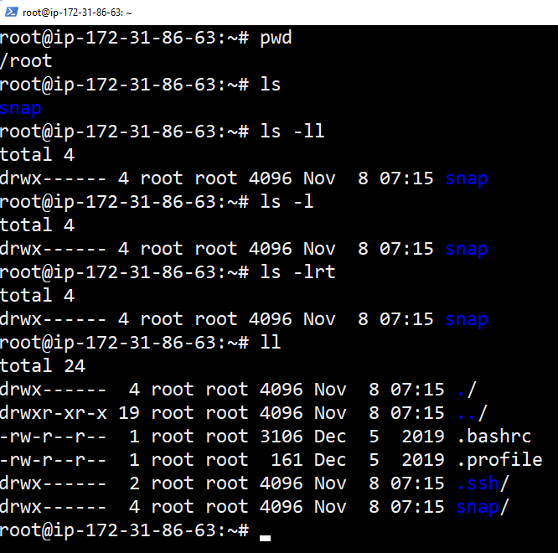

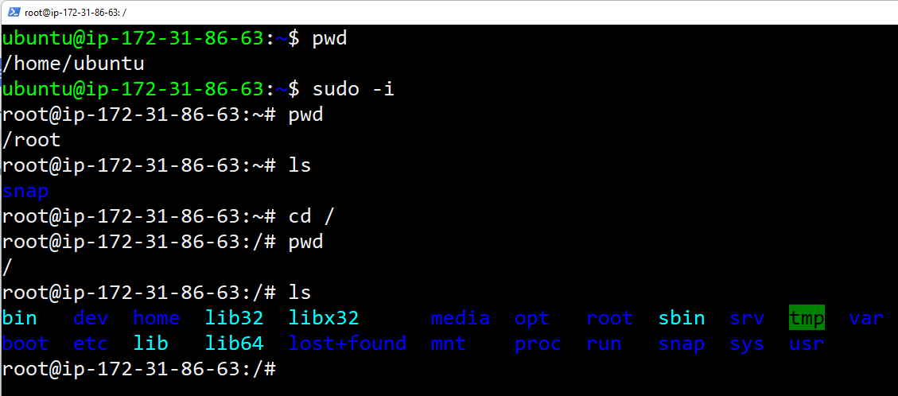

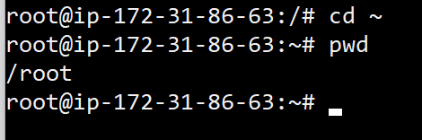

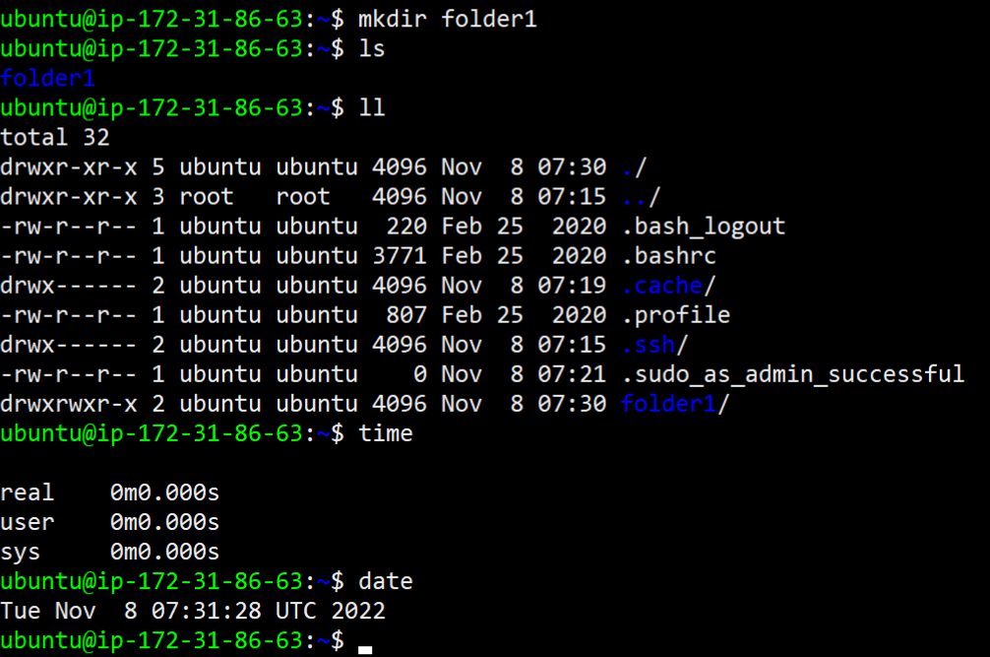

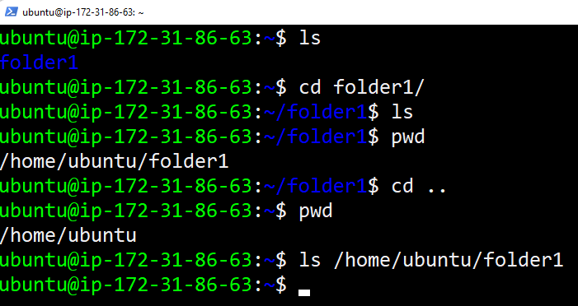

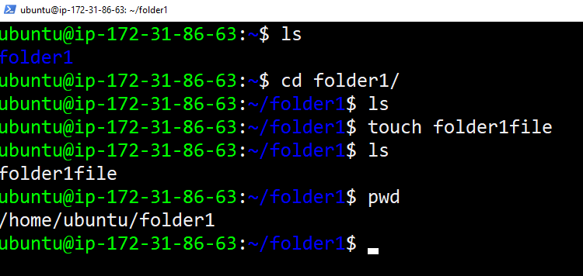

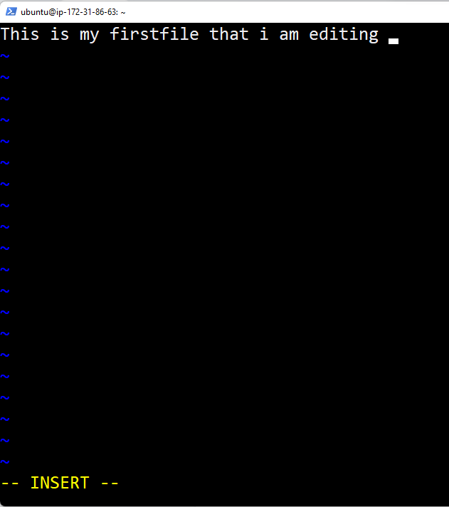

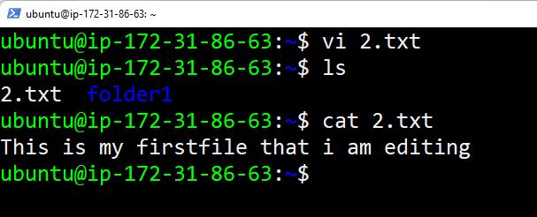

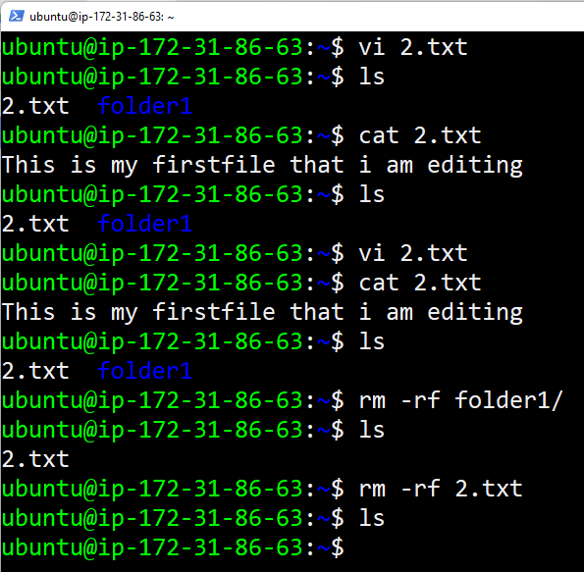

Create 50 files inside a directory and edit files and save

<https://www.ssh.com/academy/ssh/command>

LINUX CHEAT SHEET TO PRACTICE 👍

—----------------------------------------

<https://www.golinuxcloud.com/linux-commands-cheat-sheet/>

<https://www.guru99.com/linux-commands-cheat-sheet.html>

<https://www.guru99.com/linux-pipe-grep.html> [ Grep example ]

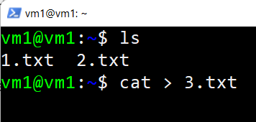

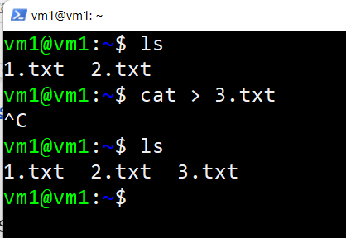

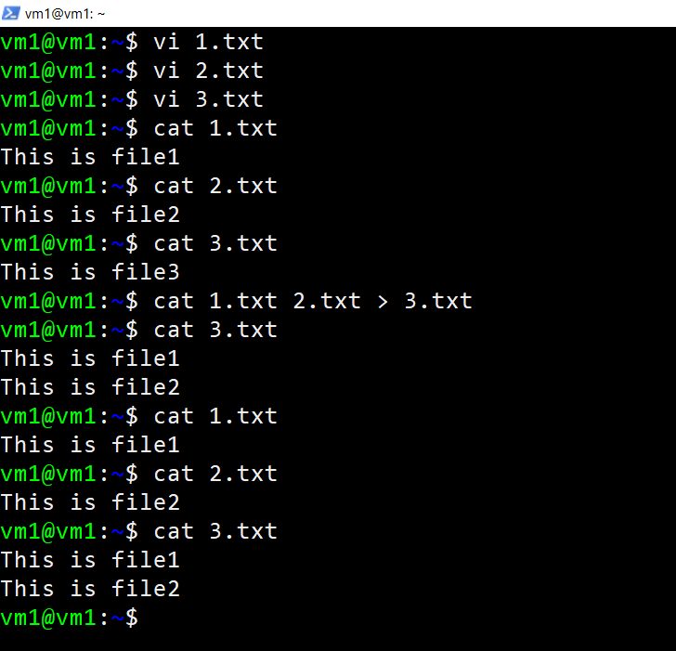

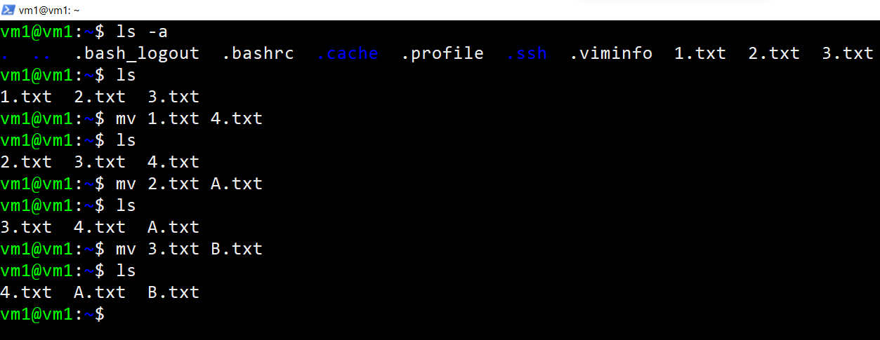

<https://linuxhint.com/cp-command-linux/>

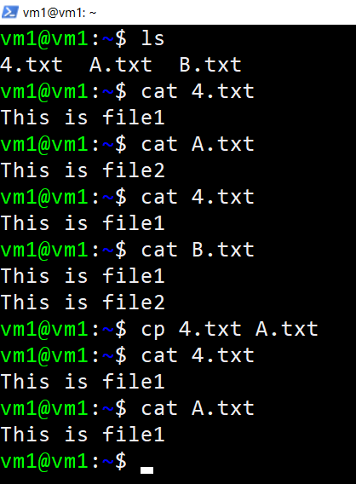

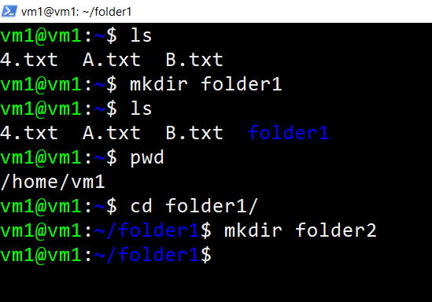

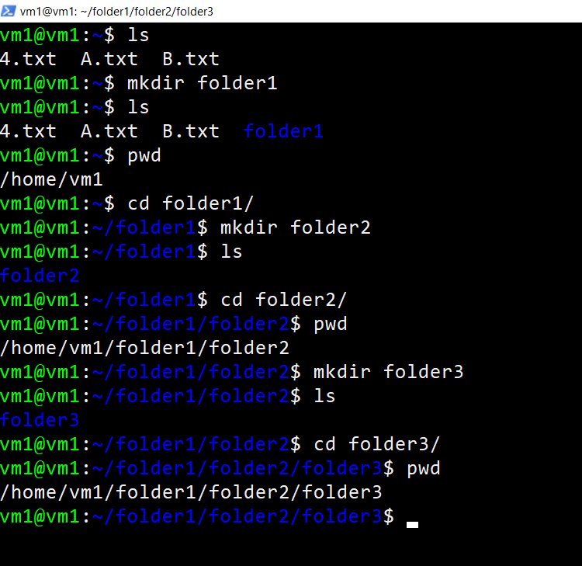

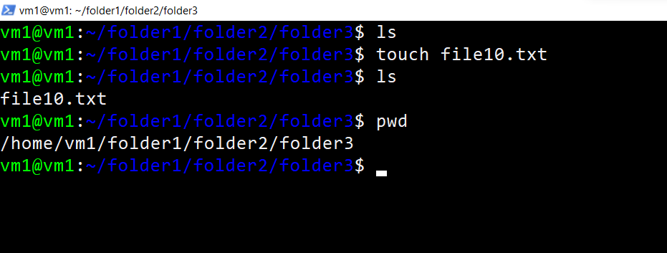

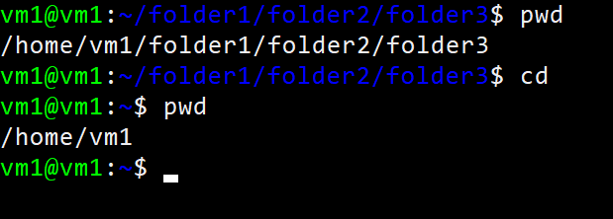

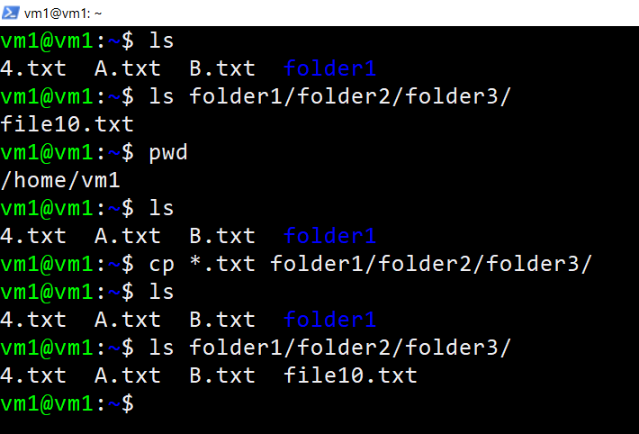

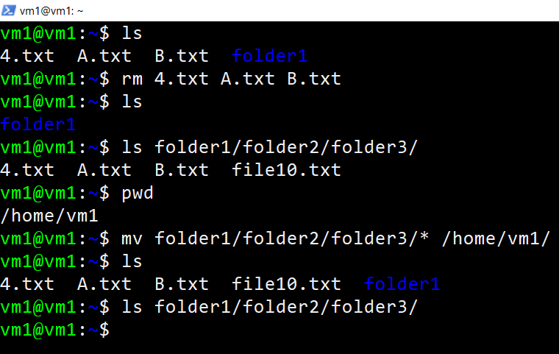

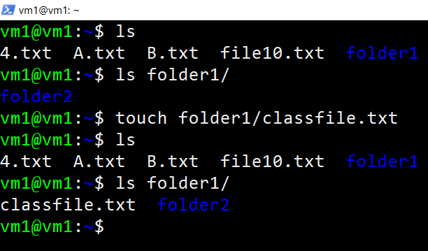

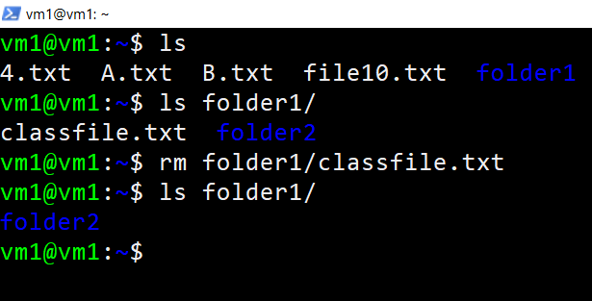

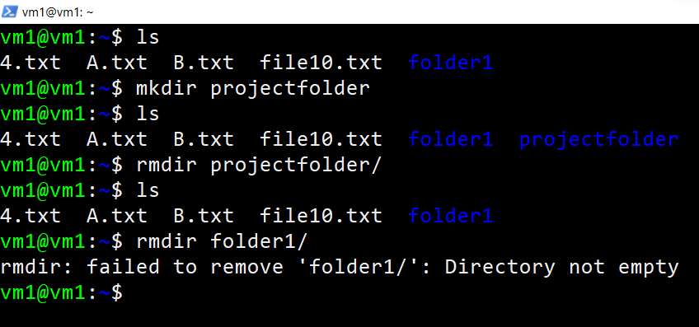

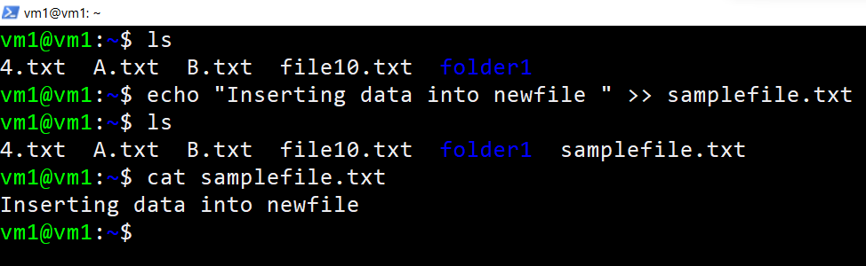

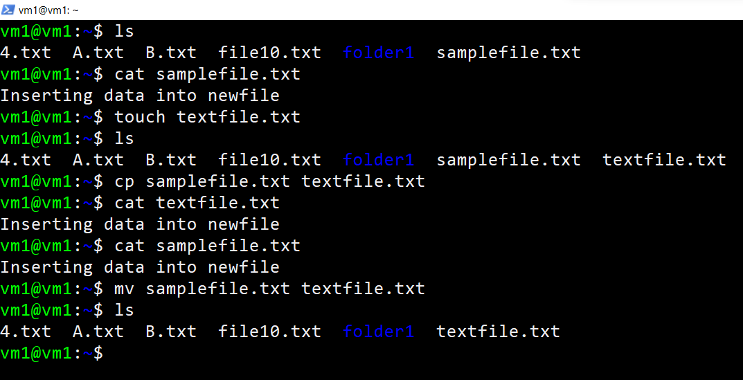

<https://www.linuxtechi.com/cp-command-examples-linux-beginners/>

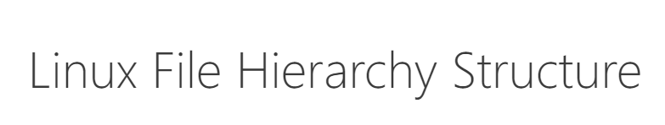

<https://www.w3schools.blog/linux-file-hierarchy-structure>

<https://linuxhint.com/linux-file-system-hierarchy/>

<https://linuxhandbook.com/>

<https://www.geeksforgeeks.org/linux-file-hierarchy-structure/>

<https://www.tecmint.com/linux-directory-structure-and-important-files-paths-explained/>

<https://www.howtogeek.com/117435/htg-explains-the-linux-directory-structure-explained/>

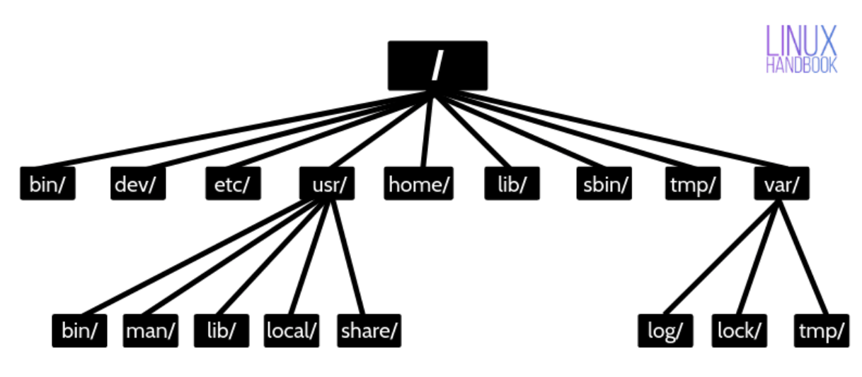

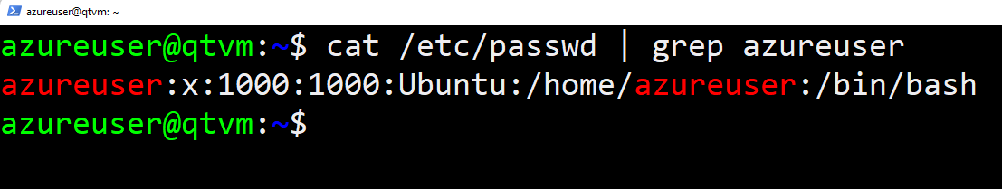

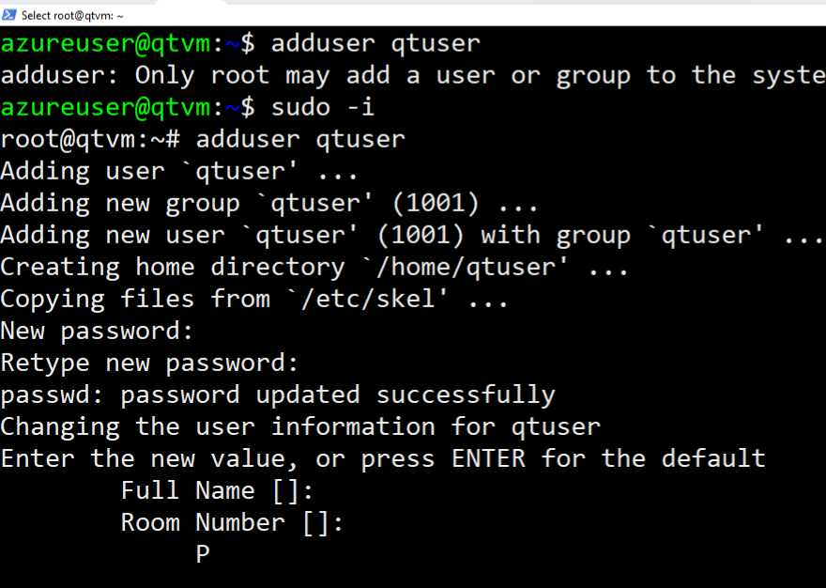

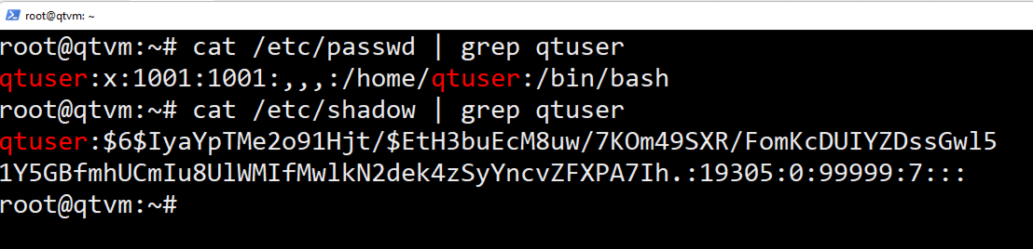

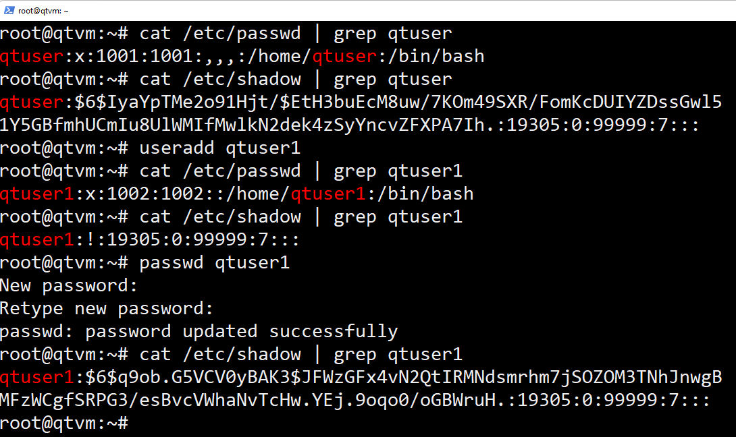

Update passwd

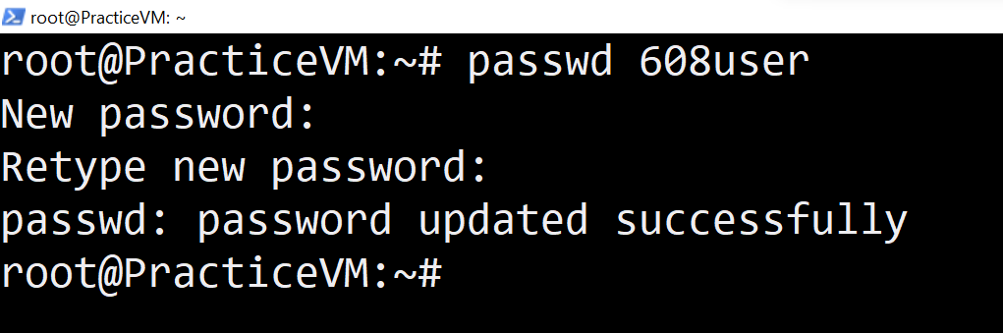

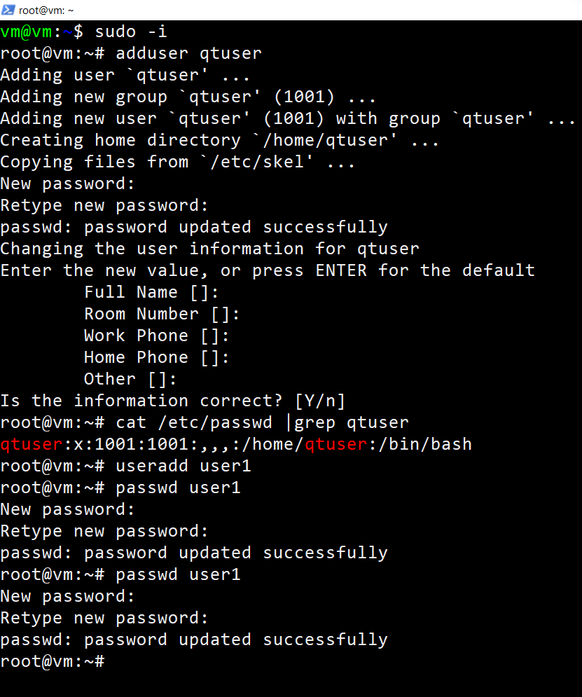

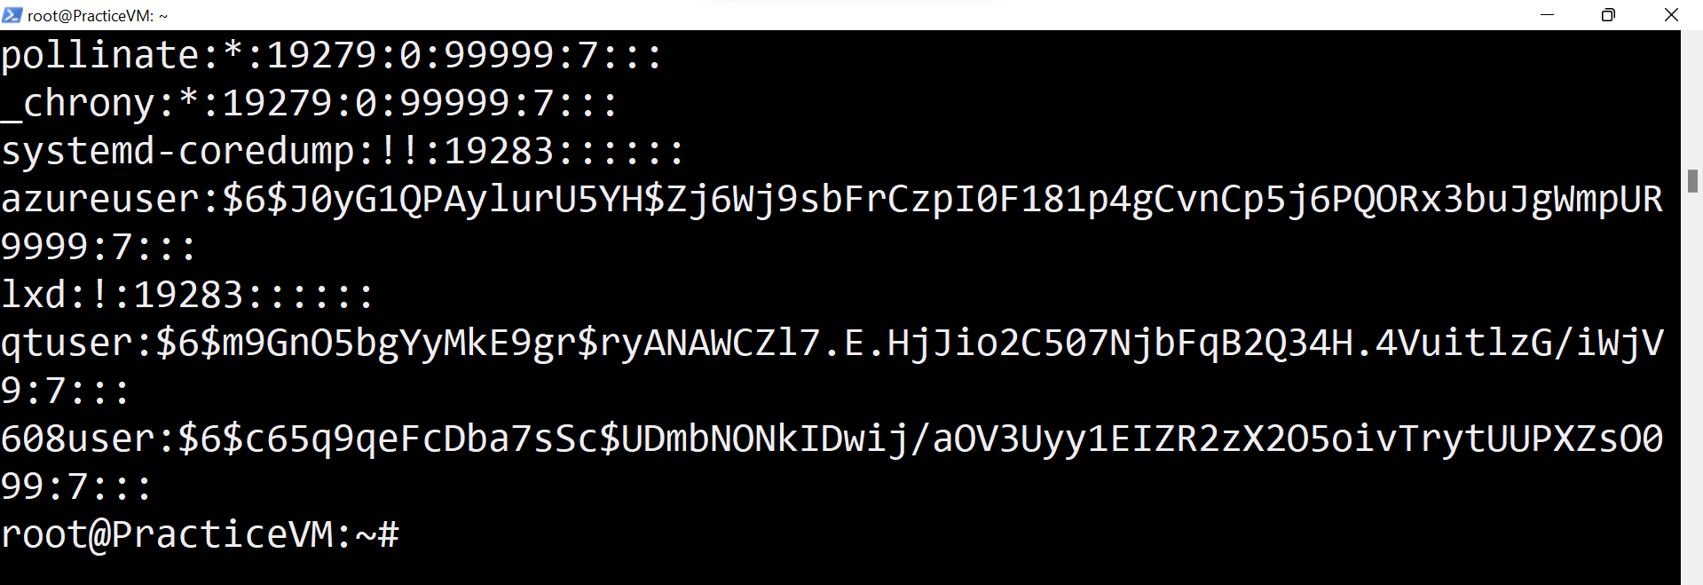

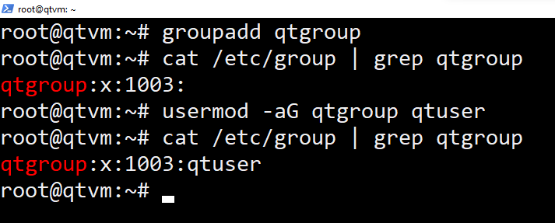

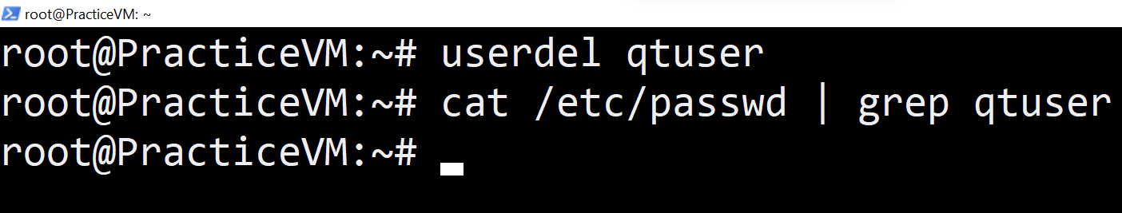

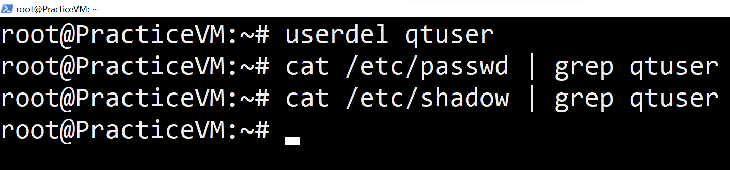

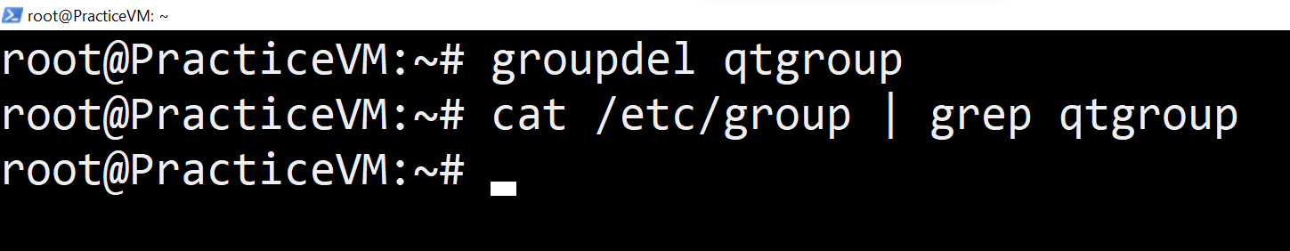

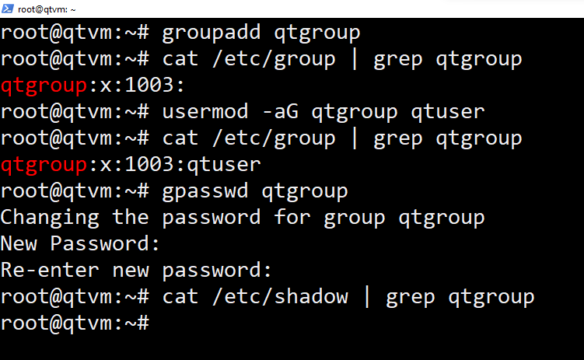

11 - 11 - 2022

—----------------

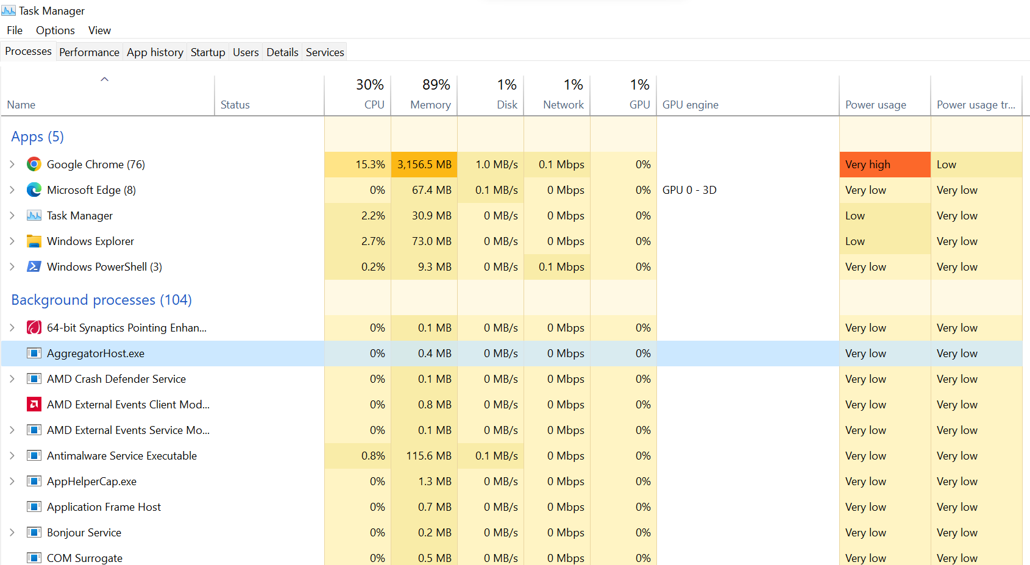

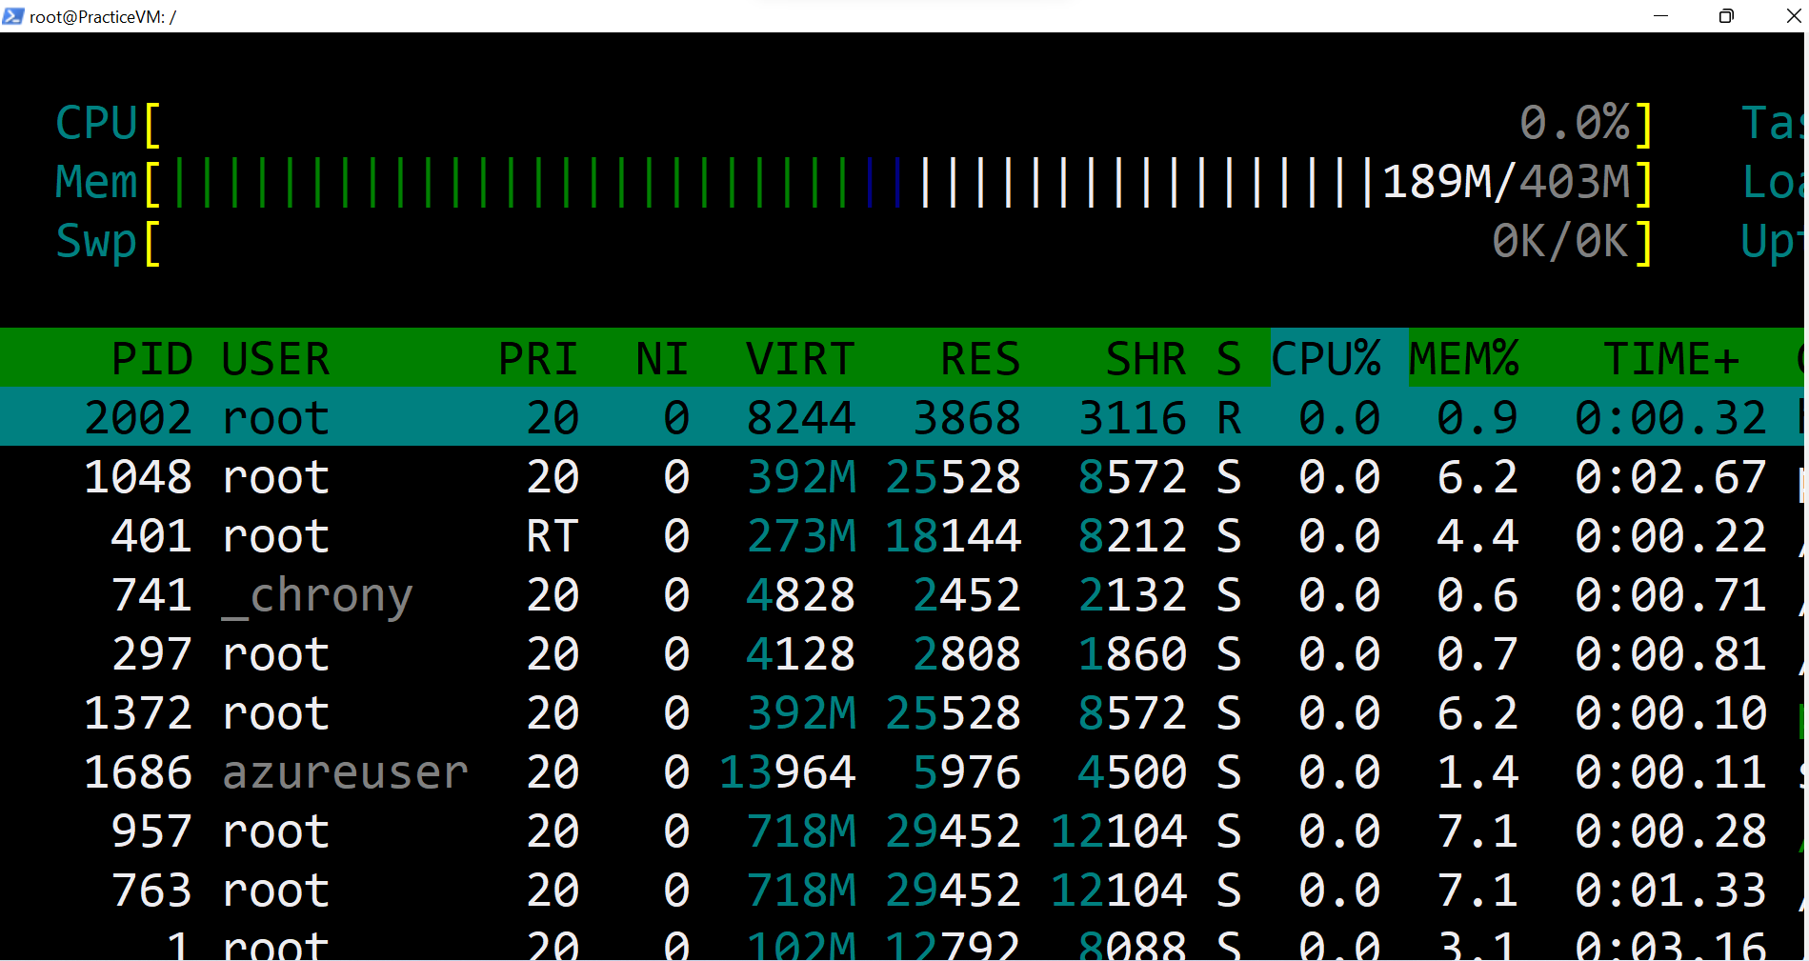

———————————

Creating 100 files at a time using Single linux command

touch file-{001..100}

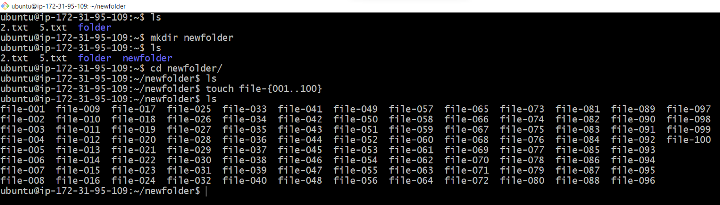

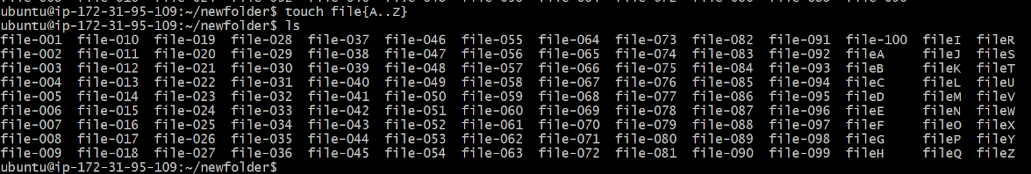



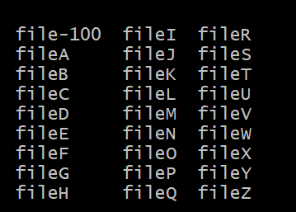

How to remove all files which you created

=> rm -f file-*

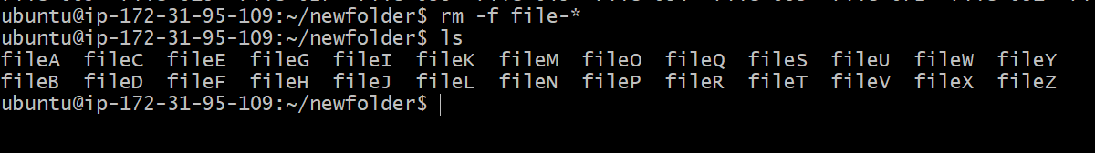

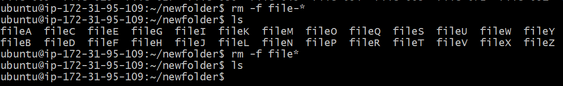

How to remove folder

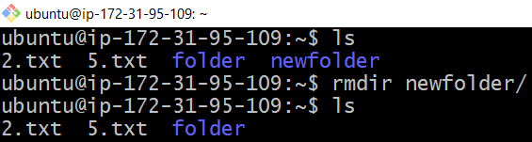

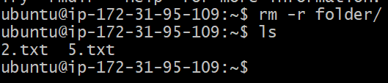

FILE PERMISSIONS IN LINUX :

—-----------------------------------------

<https://linuxize.com/post/understanding-linux-file-permissions/> { good ]

<https://www.javatpoint.com/linux-filters>

<https://www.javatpoint.com/vi-editor>

<https://www.linuxfoundation.org/blog/blog/classic-sysadmin-understanding-linux-file-permissions>

<https://www.tutorialspoint.com/unix/unix-file-permission.htm>

<https://www.geeksforgeeks.org/permissions-in-linux/#:~:text=Read%2C%20write%2C%20execute%20and%20%E2%80%93,the%20file%20is%20a%20program>.

<https://www.guru99.com/file-permissions.html>

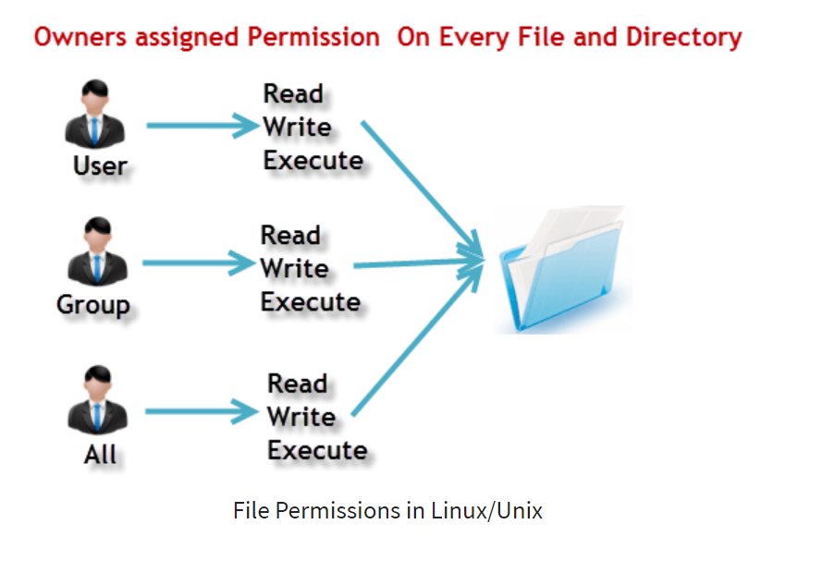

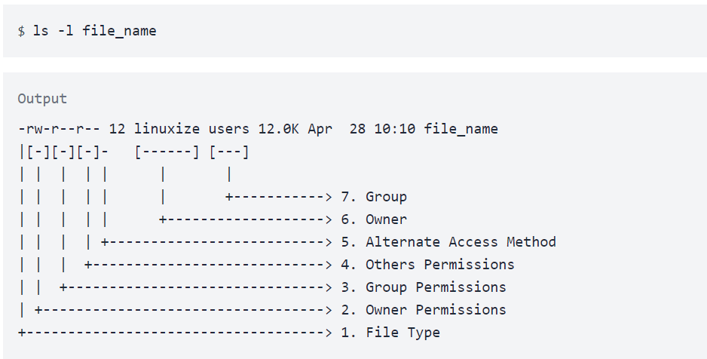

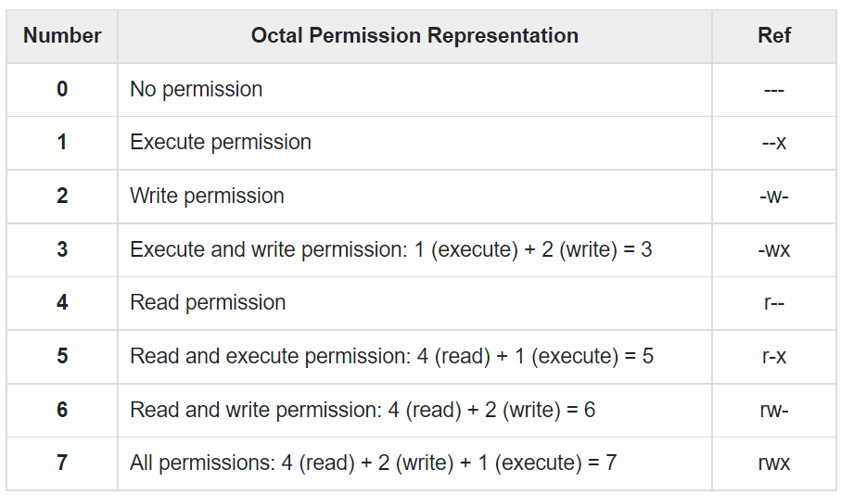

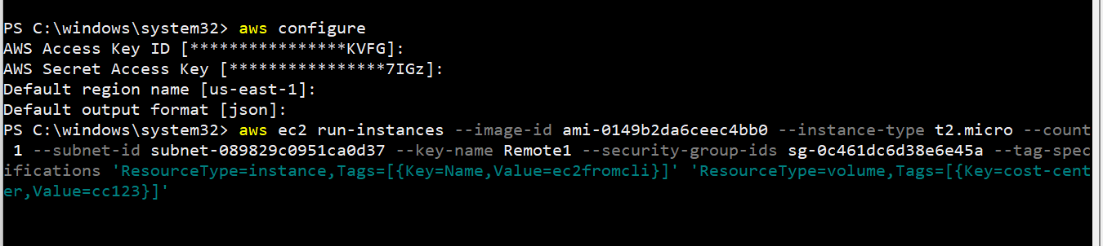

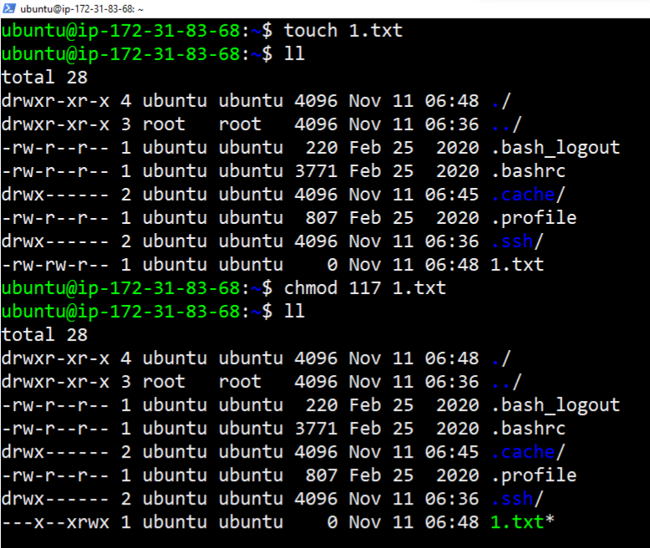

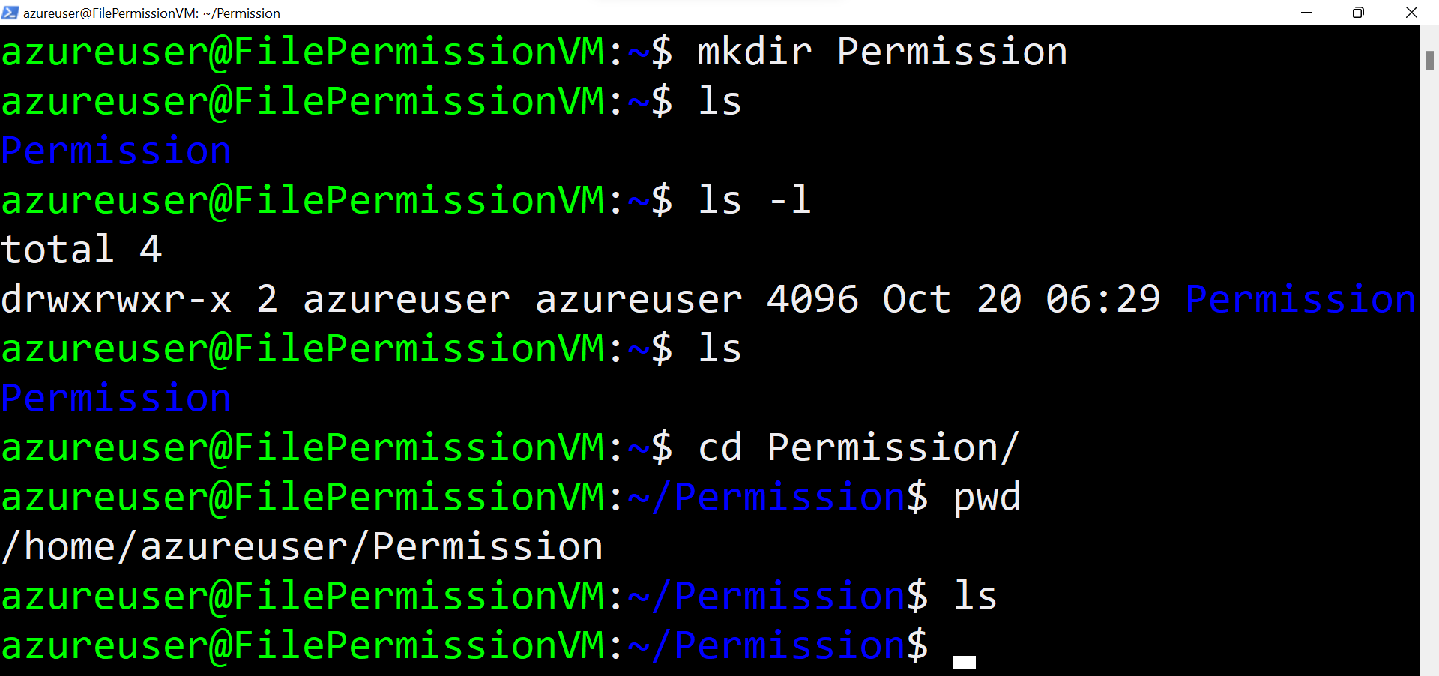

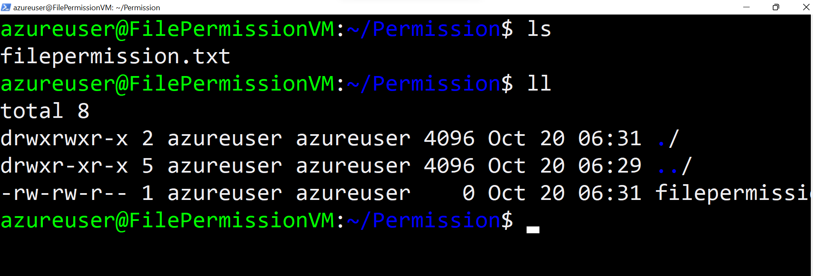



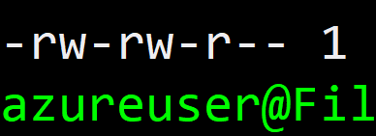

chmod 113 filepermission.txt

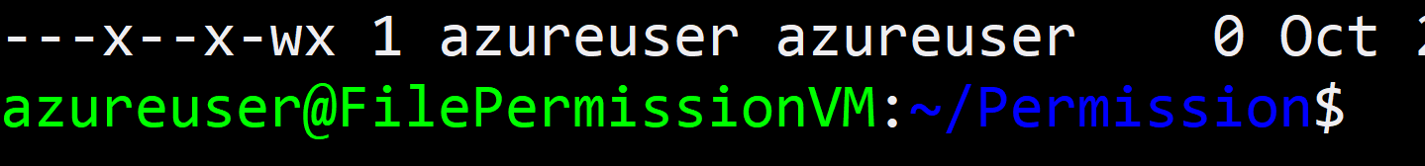









chmod 113 filepermission.txt

,

=======================

Now we will change file permissions using the alphabet .

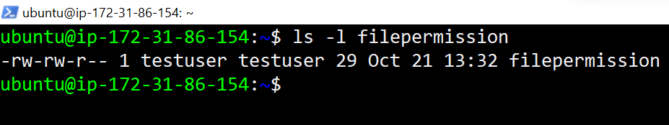

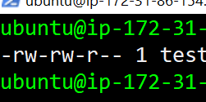

chmod o=w+x filepermission

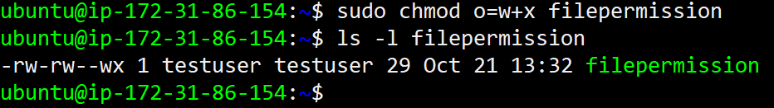

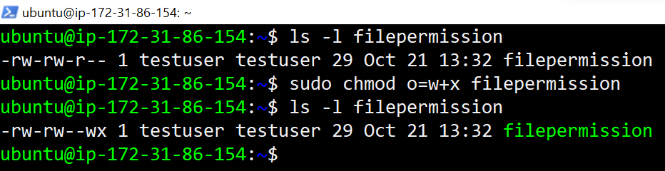

Now will change back the same permissions to that file by using numbers.

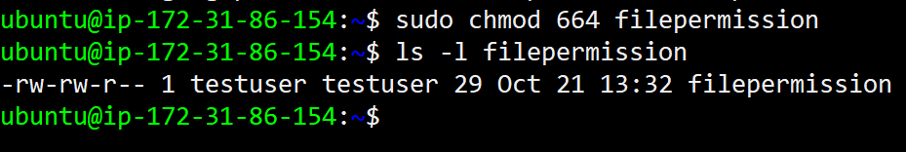

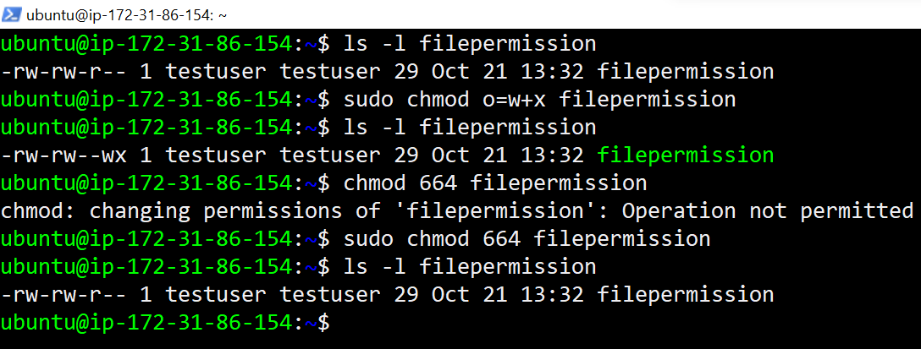

Checking File Permissions :

—----------------------------------

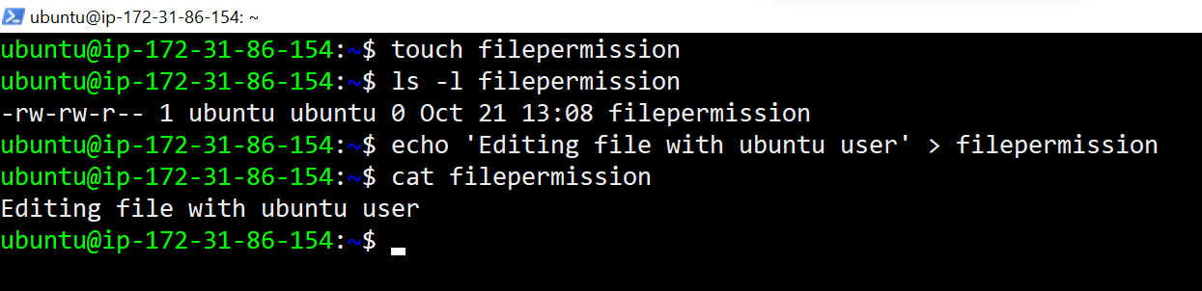

Create a user and try to open a file which is created by another user to check the file permissions.

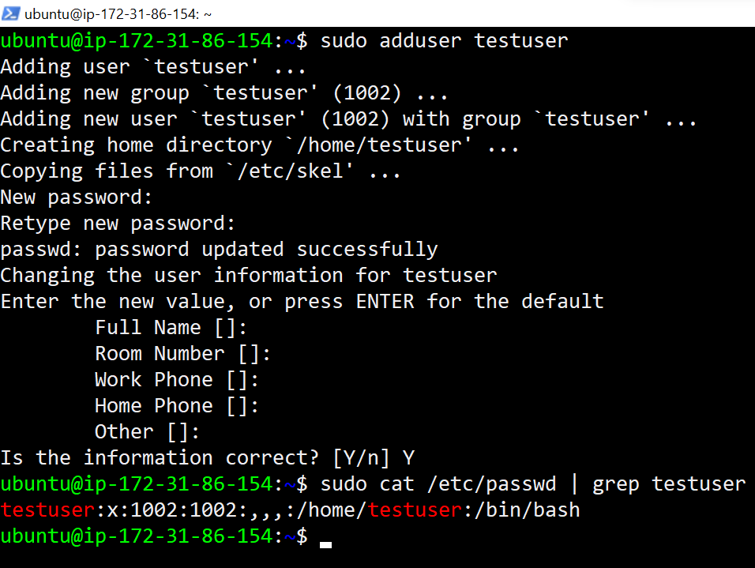

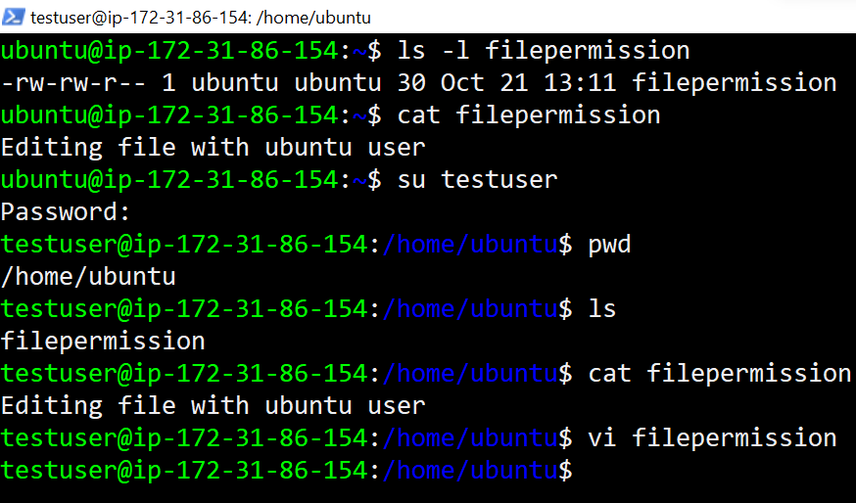

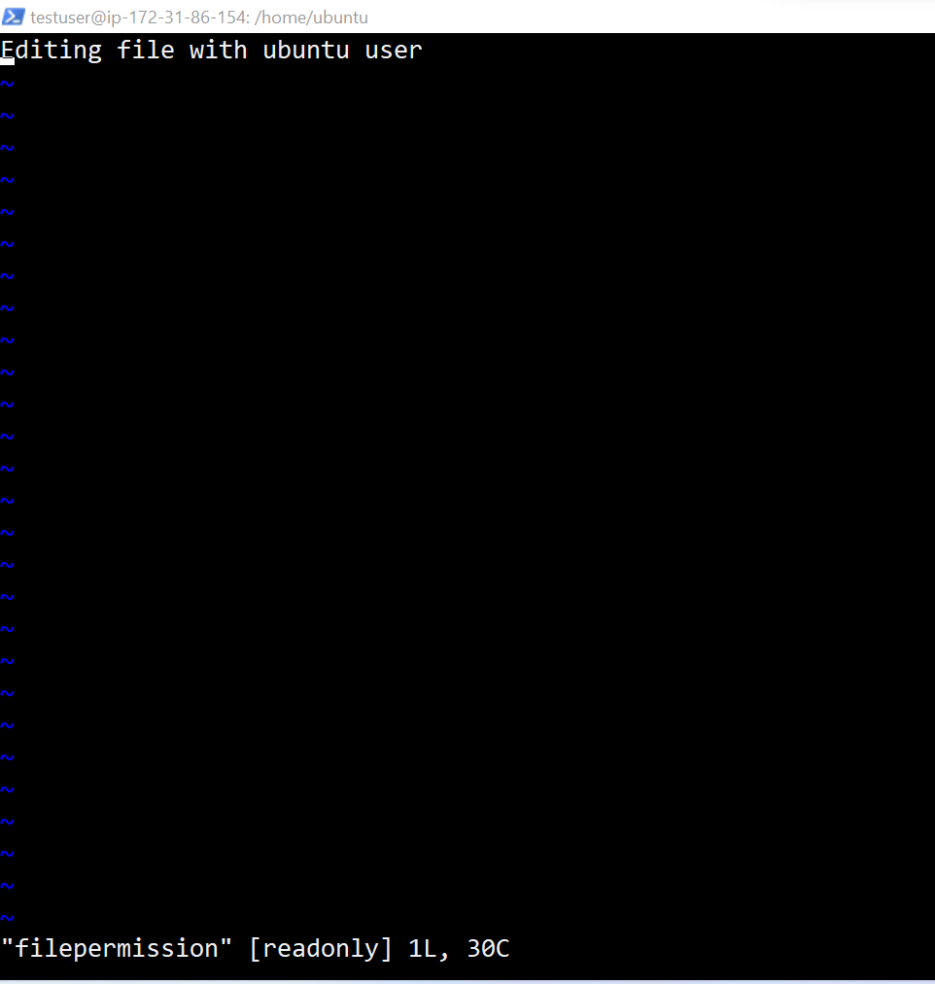

If you observer this below screenshot unable to edit the file with testuser

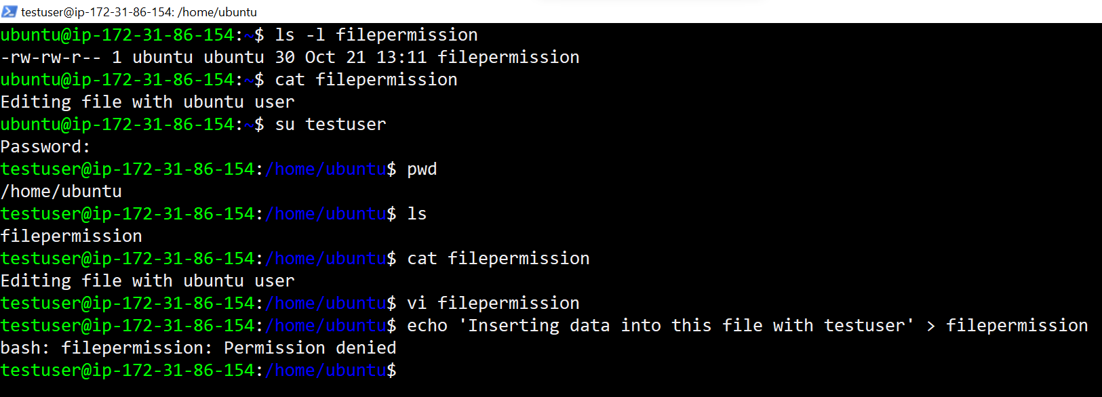

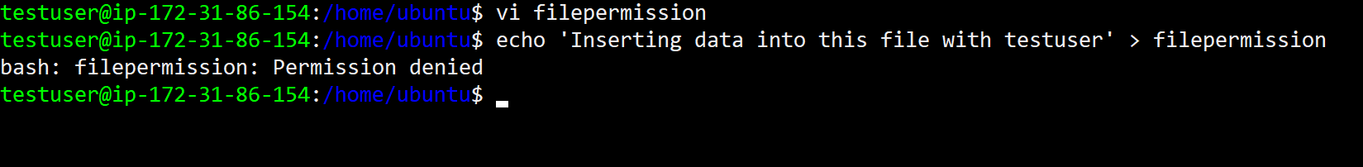

Now we are going to change the ownership to that file.

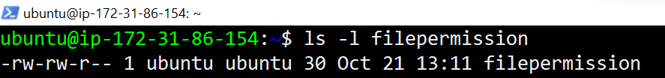

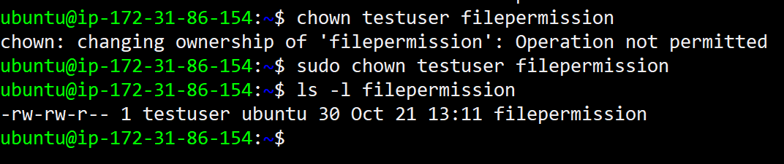



In above screenshot, unable to insert data with test user, But now I will try to open the above file using testuser.

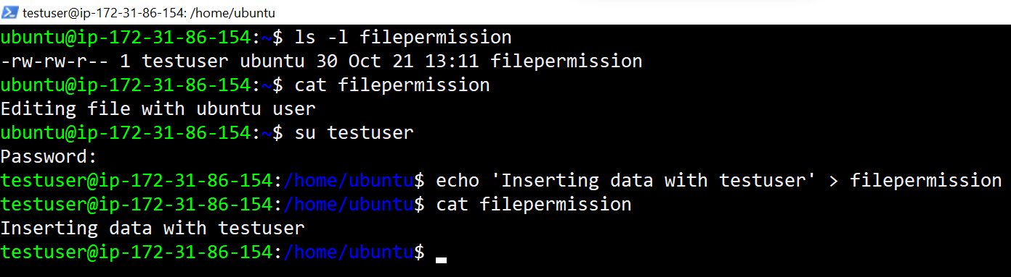

In case you want to change the user as well as group for a file or directory use the command

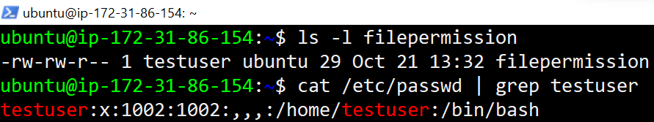

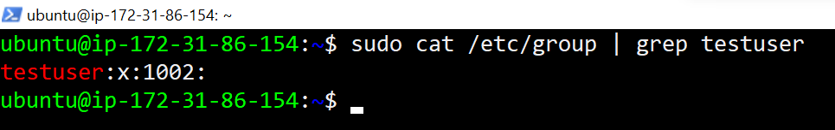

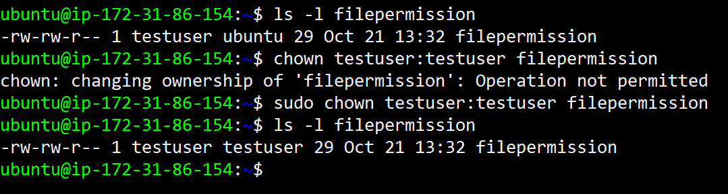

<https://www.guru99.com/file-permissions.html>

chmod ugo-rwx xyz.txt

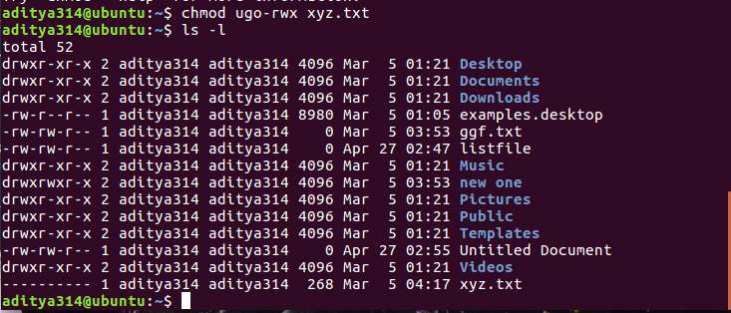

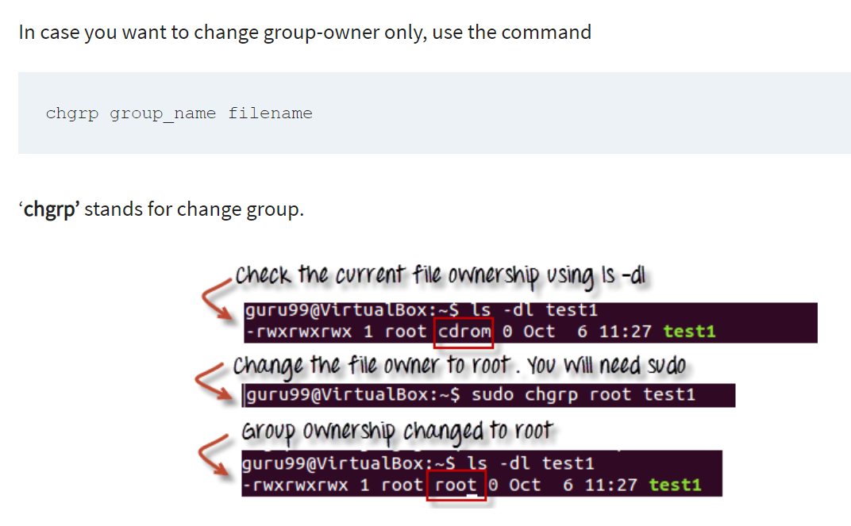

<https://www.guru99.com/linux-commands-cheat-sheet.html>

<https://www.guru99.com/linux-pipe-grep.html>

Change Passwords 👍

—----------------------------

<https://www.cyberciti.biz/faq/linux-set-change-password-how-to/>

Chown

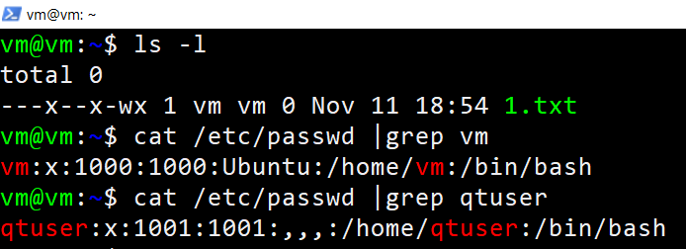

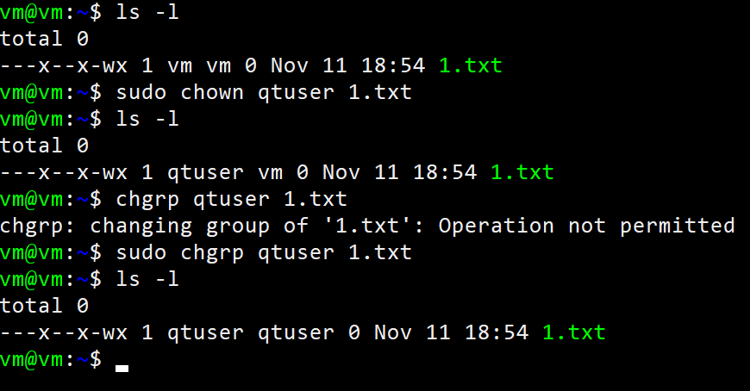

Chgrp

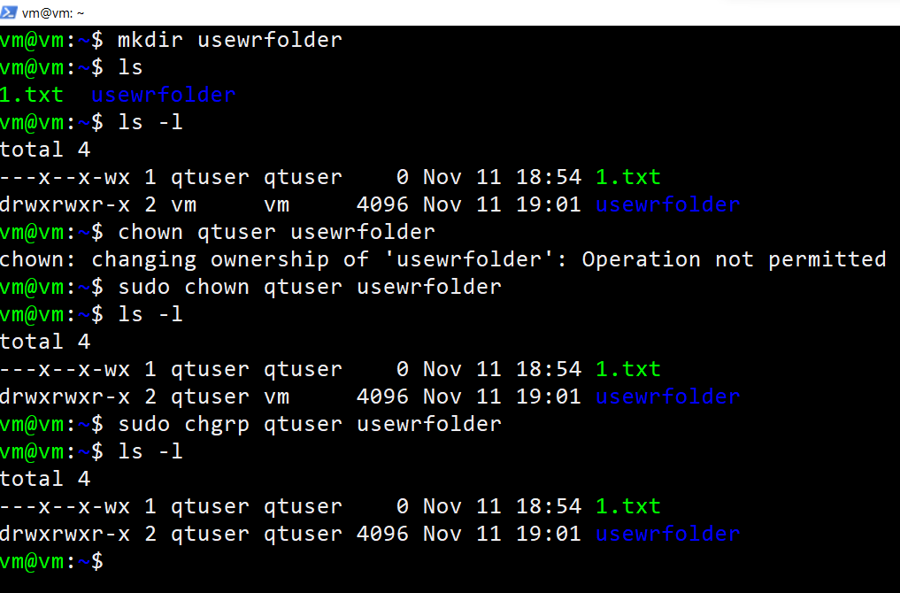

Checking permissions :

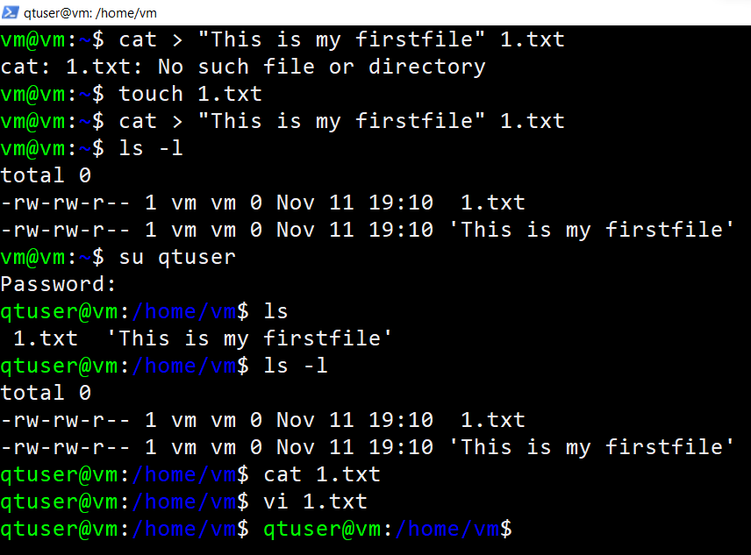

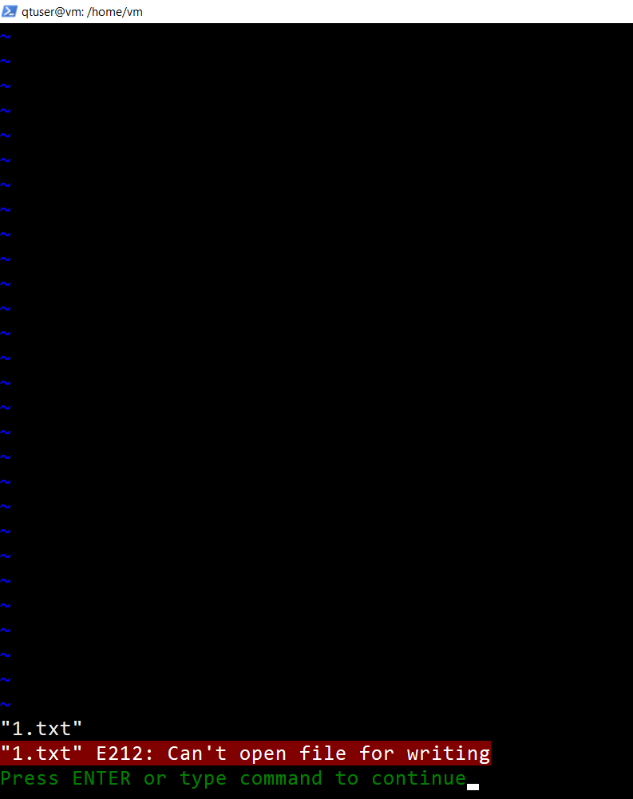

In powershell 👍

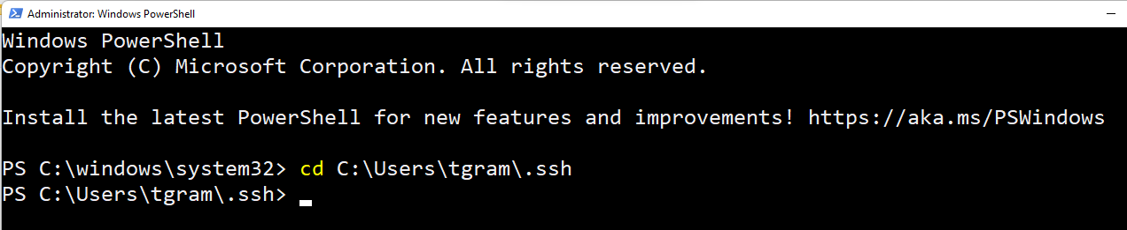

In Gitbash

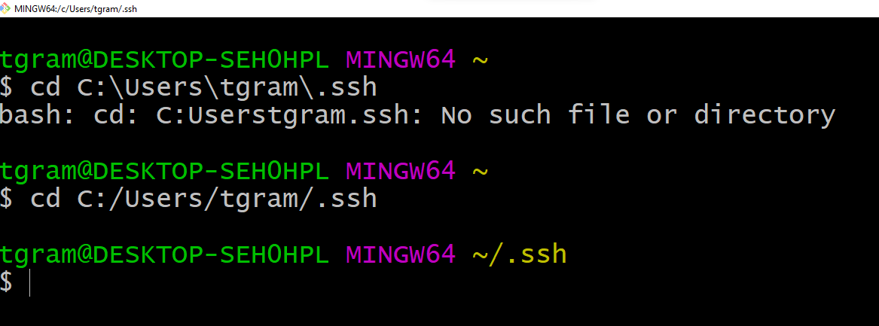

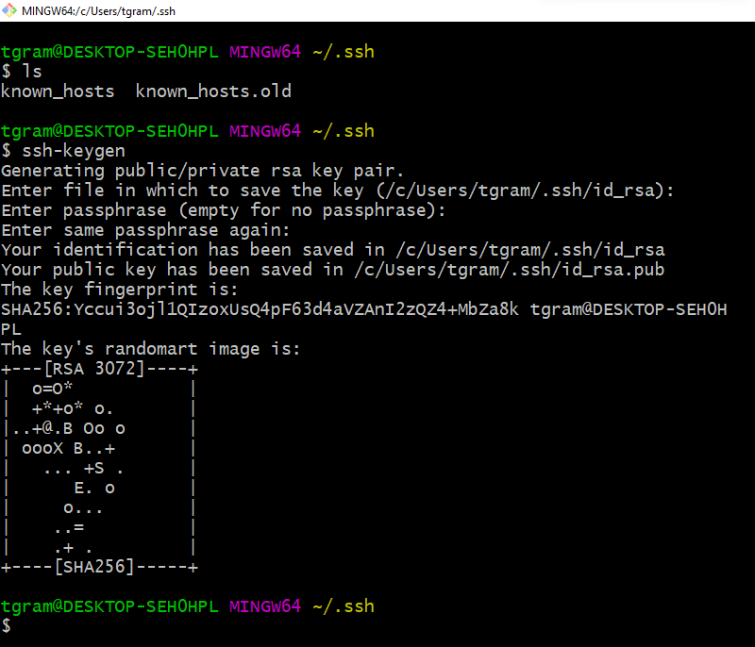

AZURE

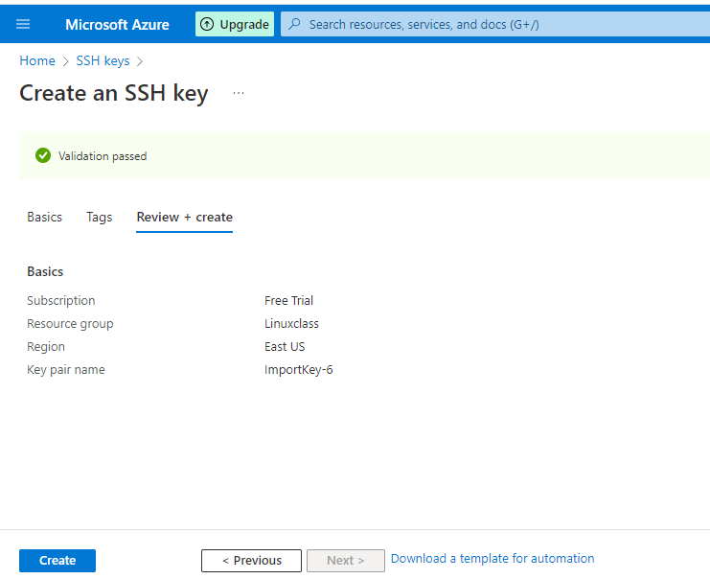

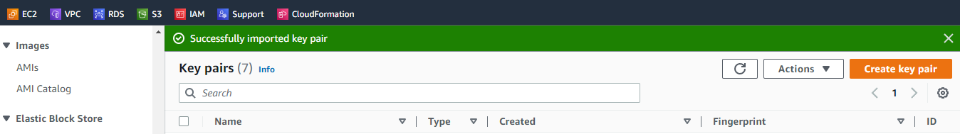

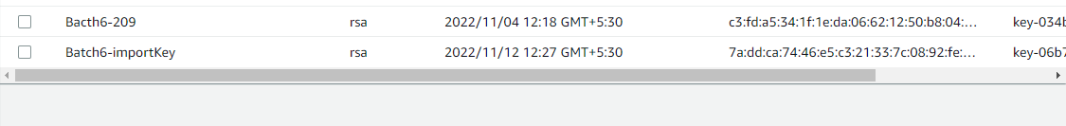

<https://docs.google.com/spreadsheets/d/1fInZzaGjimYFgSzodDeg7zaL1TkgZU9_qKIK36eYzV0/edit?usp=sharing>

INSTALL APACHE2 ON UBUNTU 20.04 👍

—--------------------------------------------

<https://www.digitalocean.com/community/tutorials/how-to-install-the-apache-web-server-on-ubuntu-20-04>

<https://www.w3schools.com/html/tryit.asp?filename=tryhtml_basic_document> [ Sample HTML Code ]

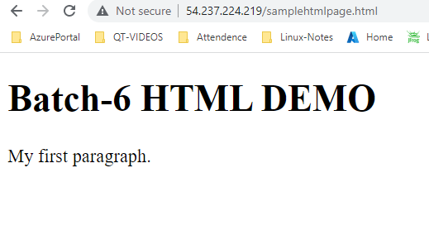

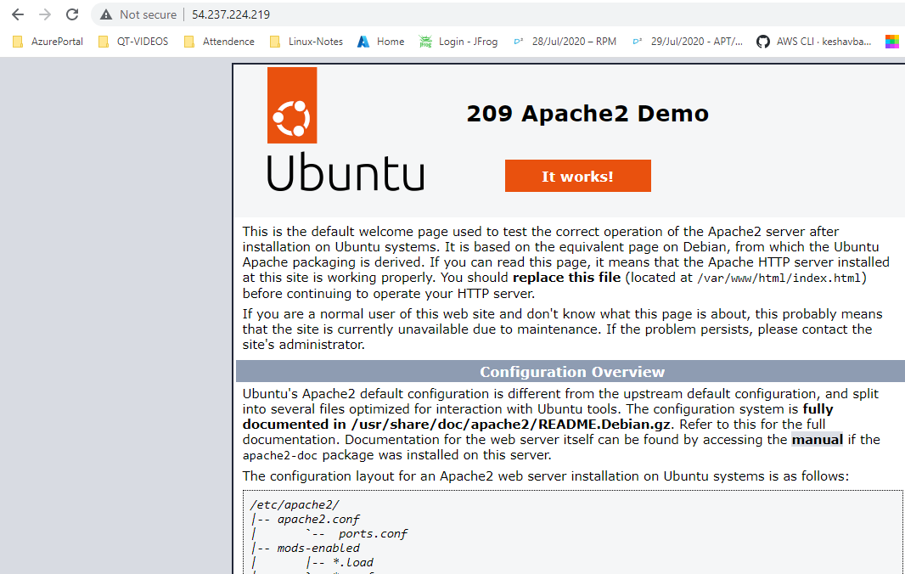

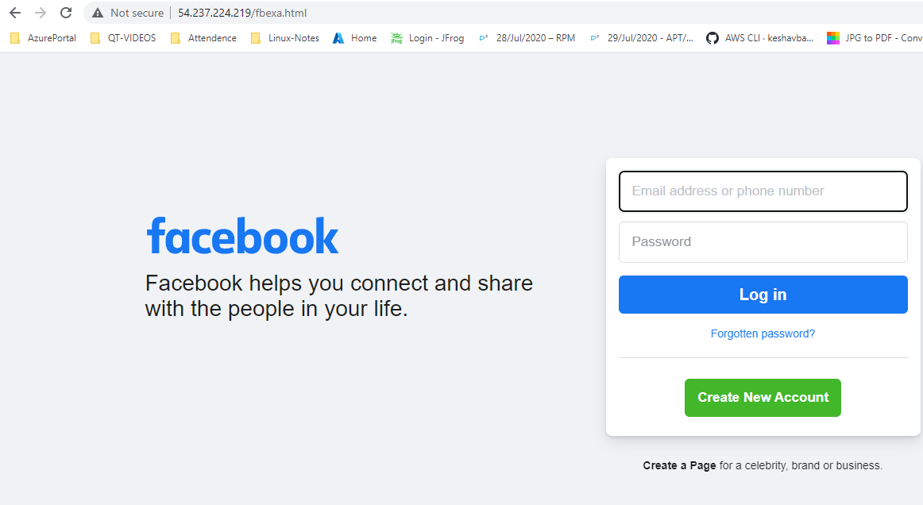

INSTALL HTTPD ON CENTOS 7  
—----------------------------------

<https://www.digitalocean.com/community/tutorials/how-to-install-the-apache-web-server-on-centos-7>

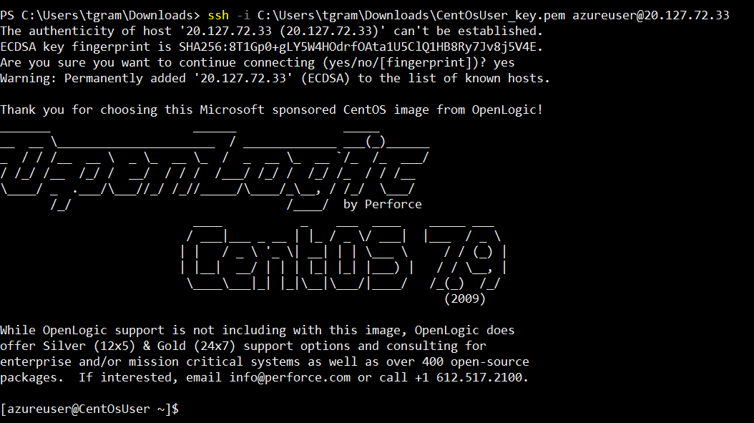

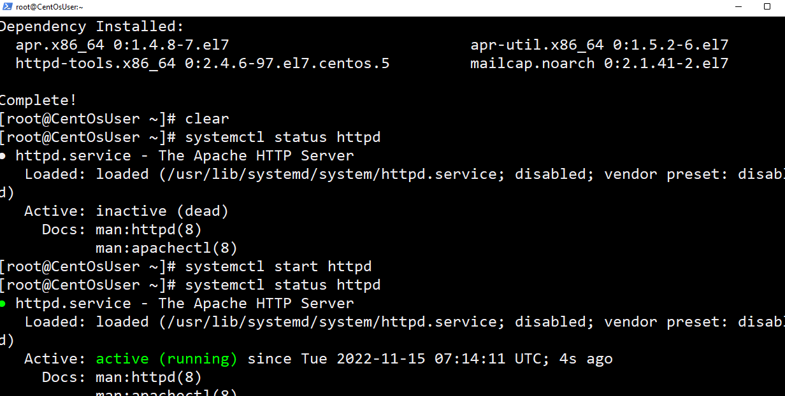

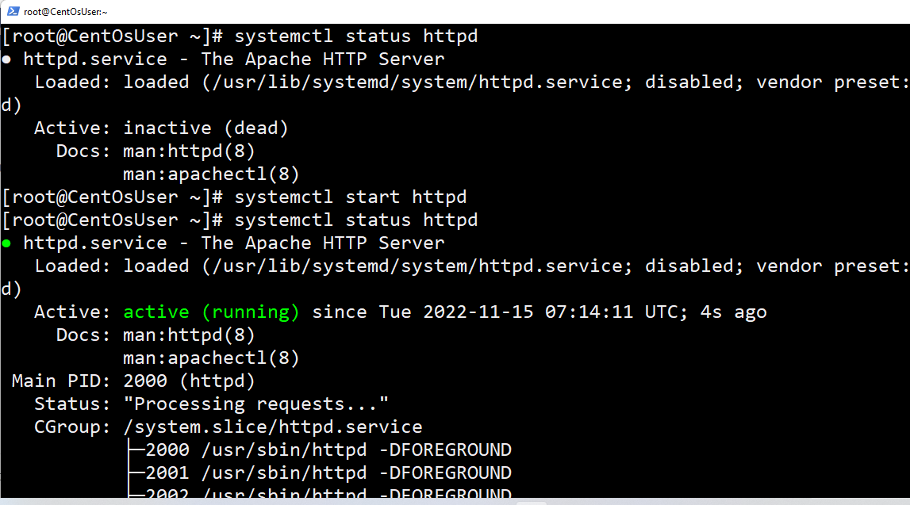

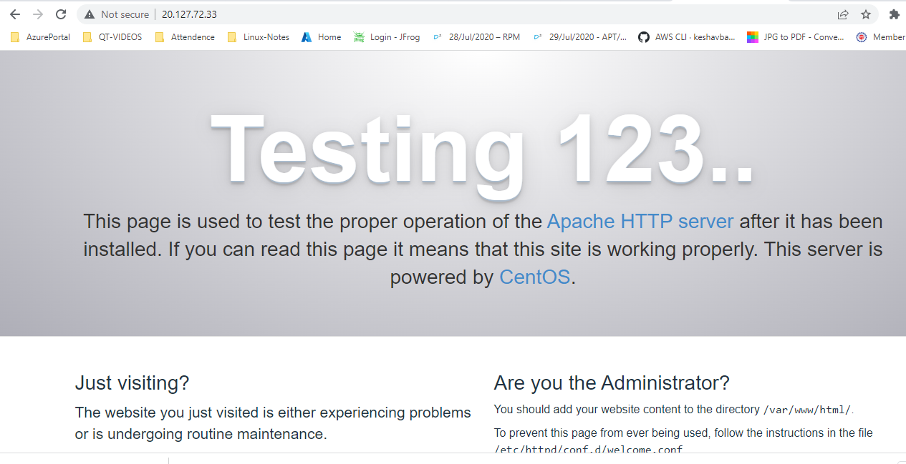

UPLOAD CONTENT (OR) DATA USING SFTP INTO REMOTE MACHINE

[ EC2/VM ]

—----------------------------------------------------------------------------

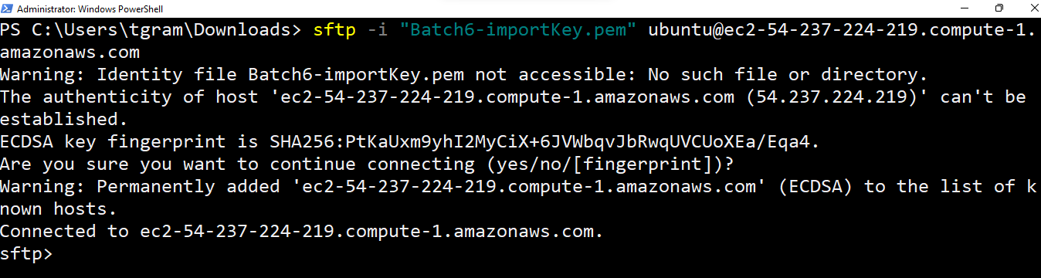

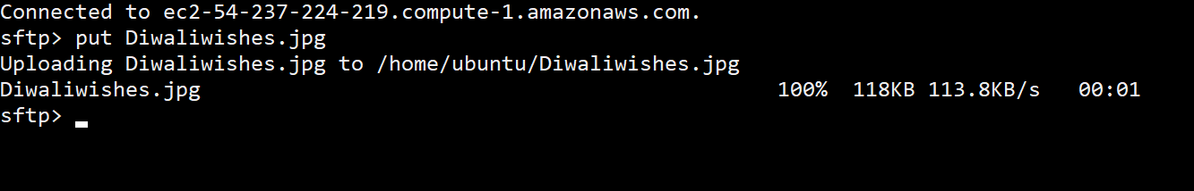

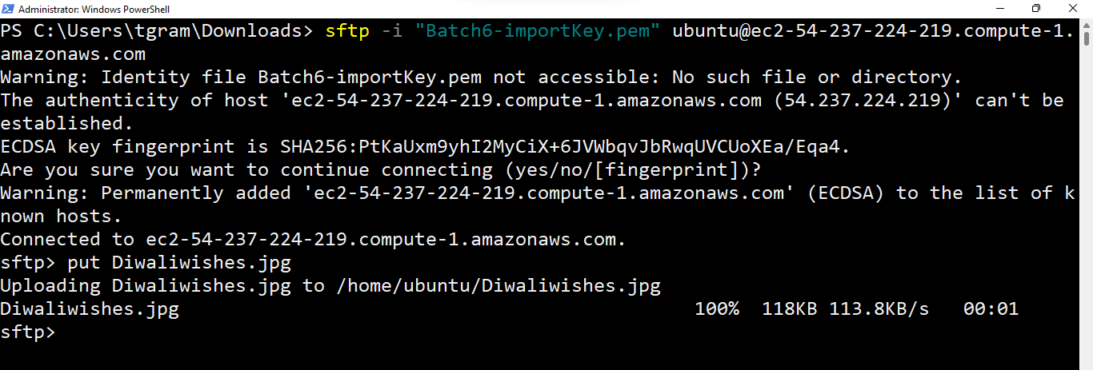

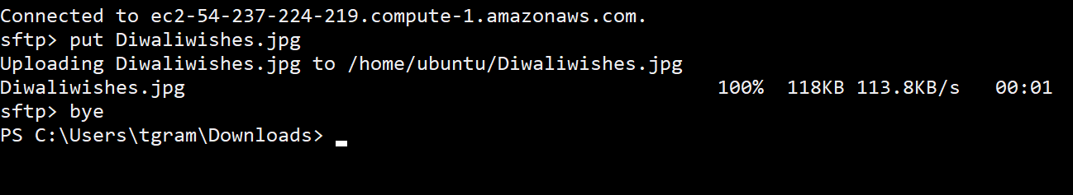

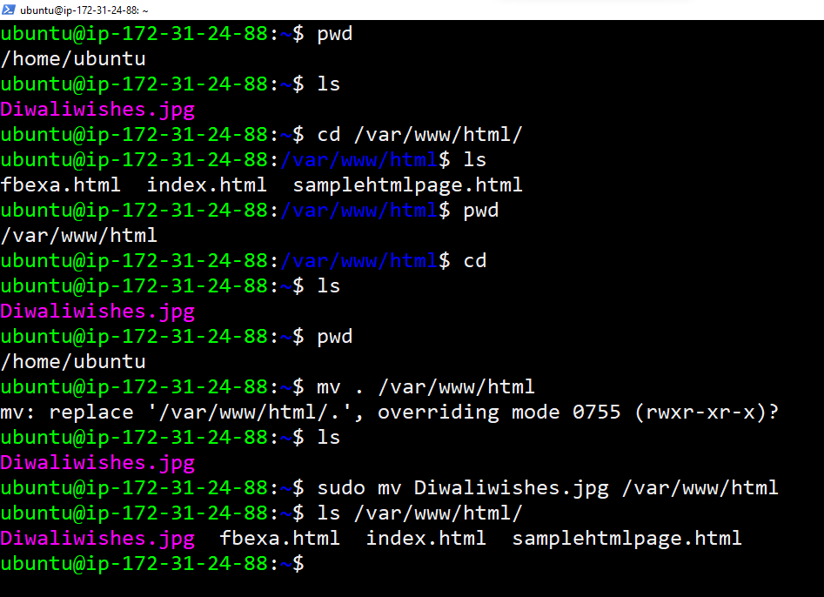



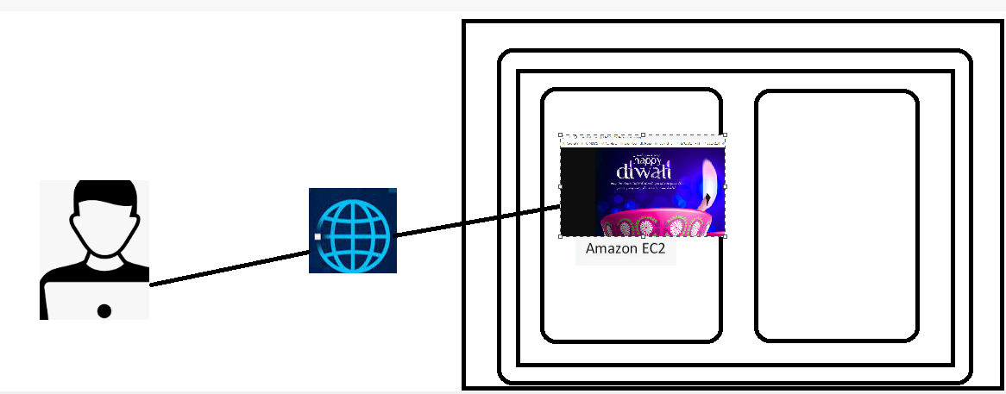

About visudo / sudoers 👍

—-------------------------------

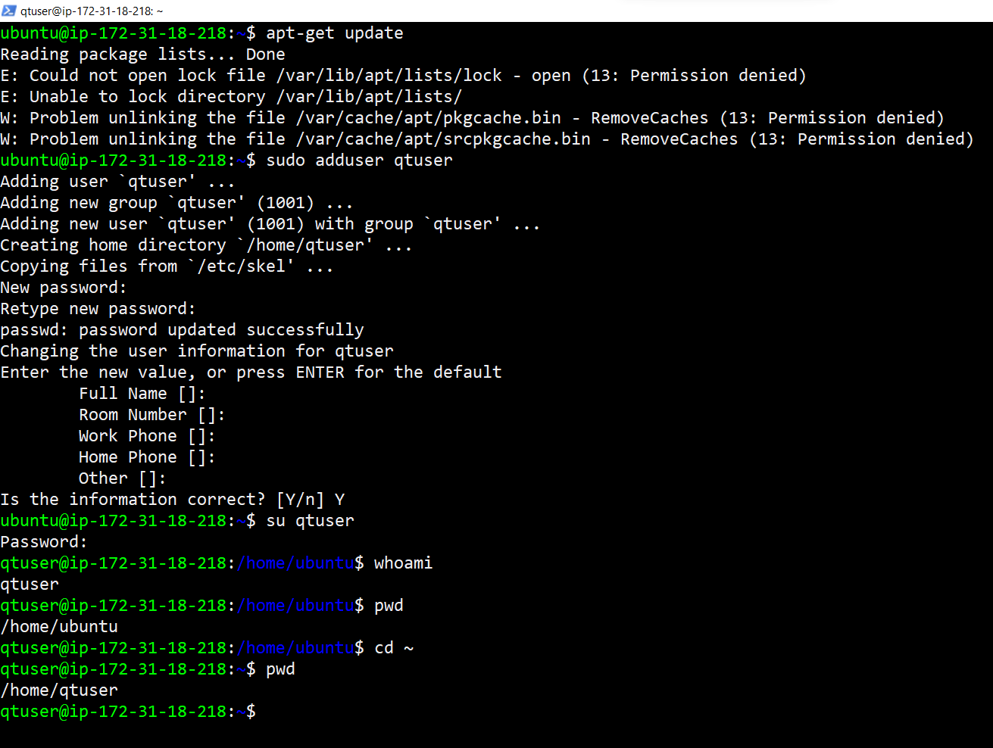

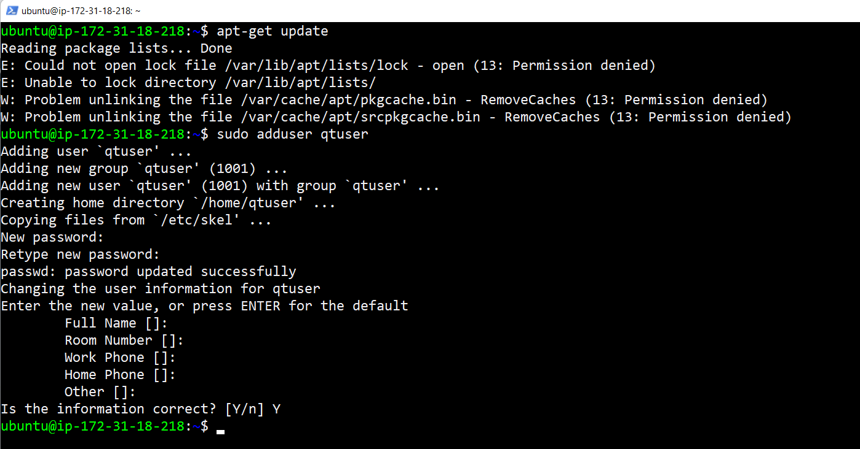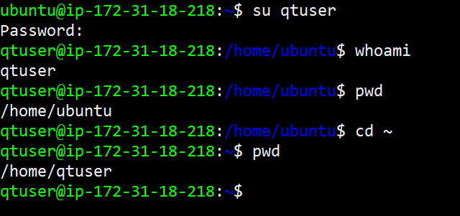

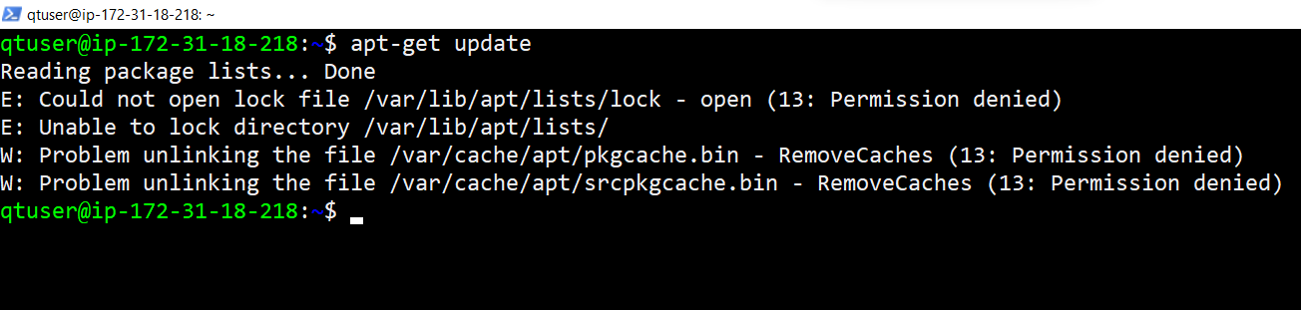

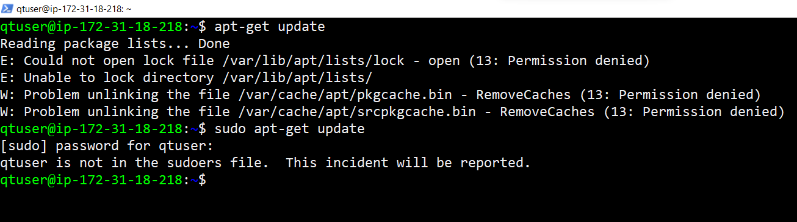

But sudo apt-get update is working for ubuntu

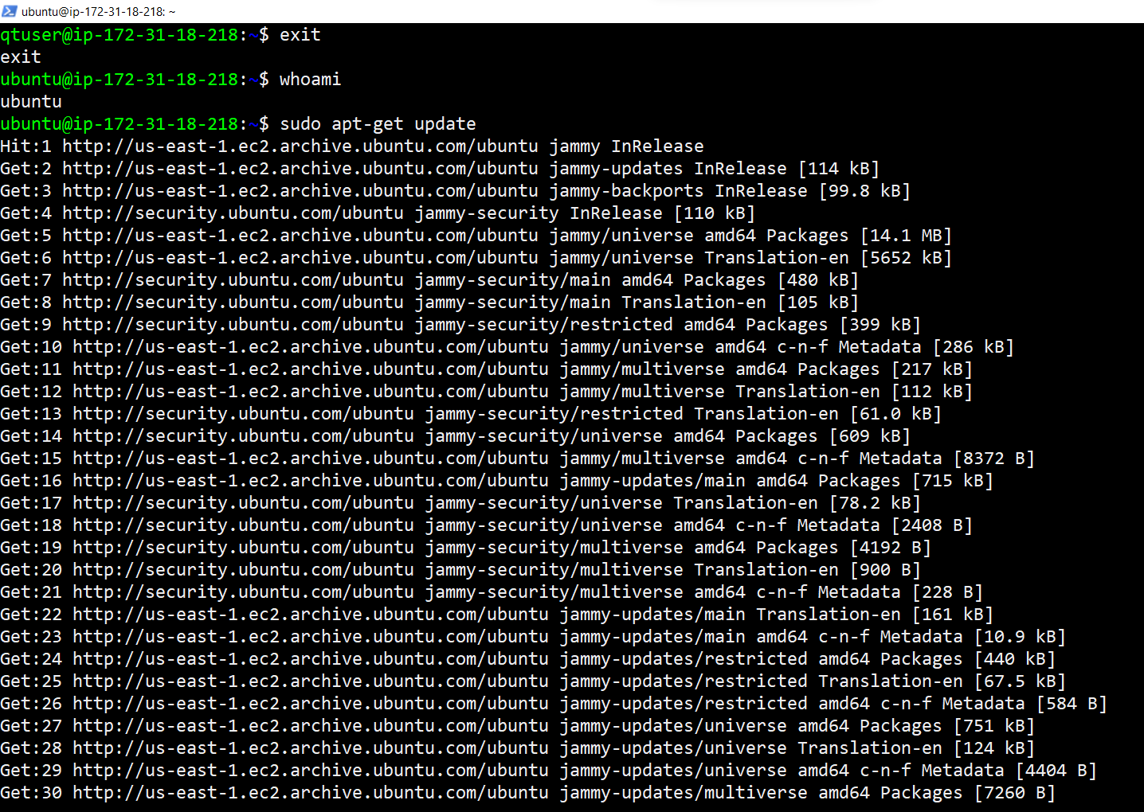

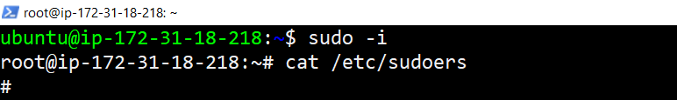

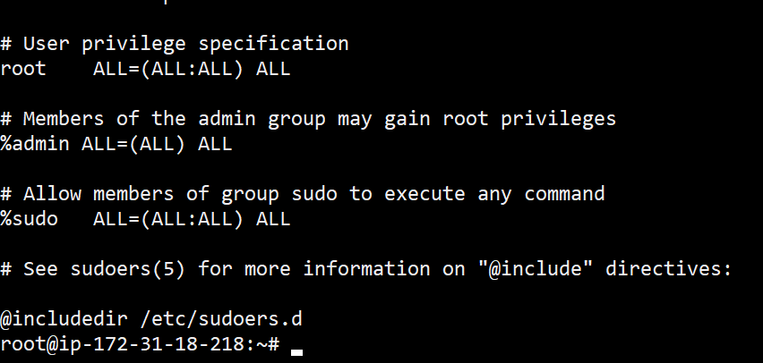

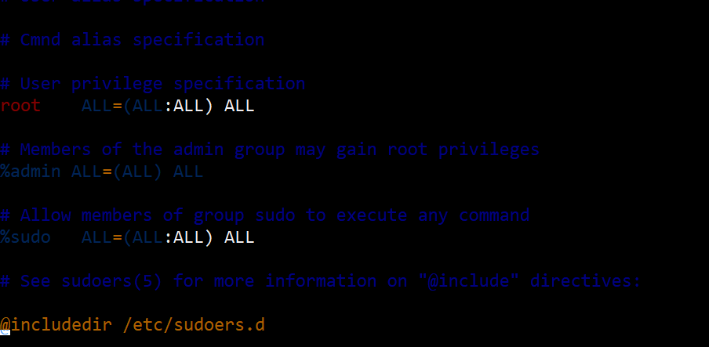

Added qtuser into sudoers file

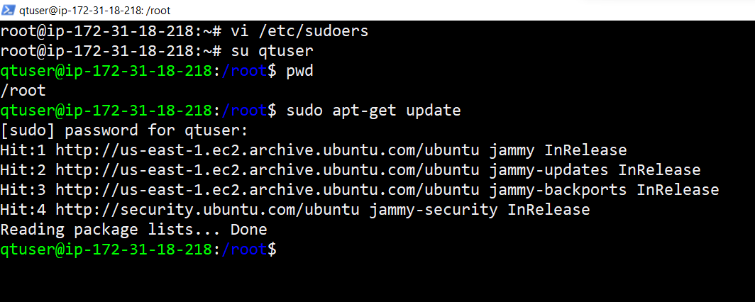

And earlier if you wanted to do update packages it is asking for password

But we can also do the update without asking for the password by using the below procedure.

<https://phpraxis.wordpress.com/2016/09/27/enable-sudo-without-password-in-ubuntudebian/>

<https://www.linuxfordevices.com/tutorials/linux/sudo-nopasswd>

<https://linuxhint.com/setup-sudo-no-password-linux/>

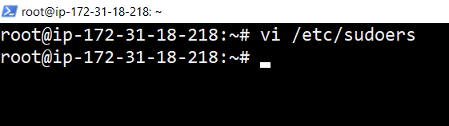

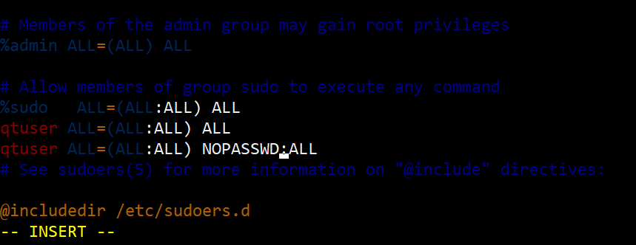

After making the above changes it is not asking for the password while executing sudo apt-get update

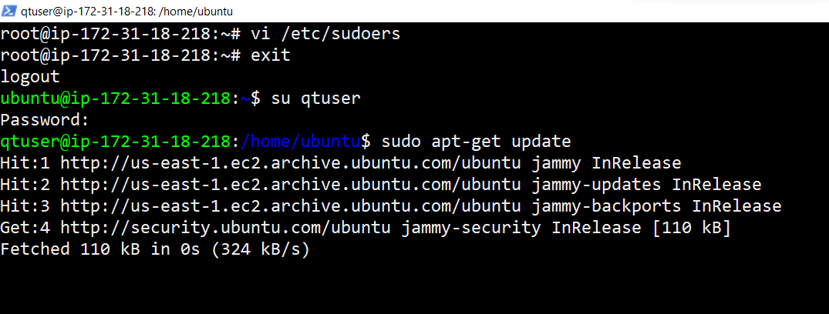

If you remove the NOPASSWD:ALL Line from sudoers file it will be as usual as below shown [ It will ask you for the password ]

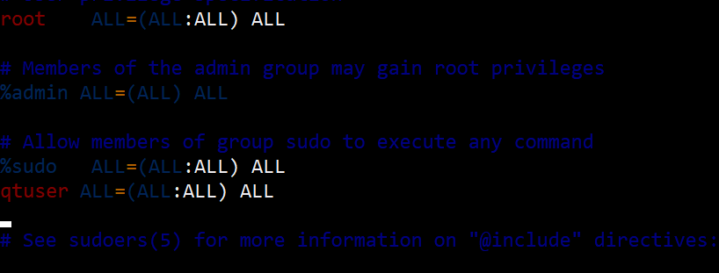

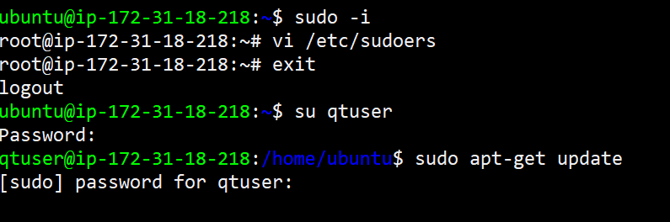

================================

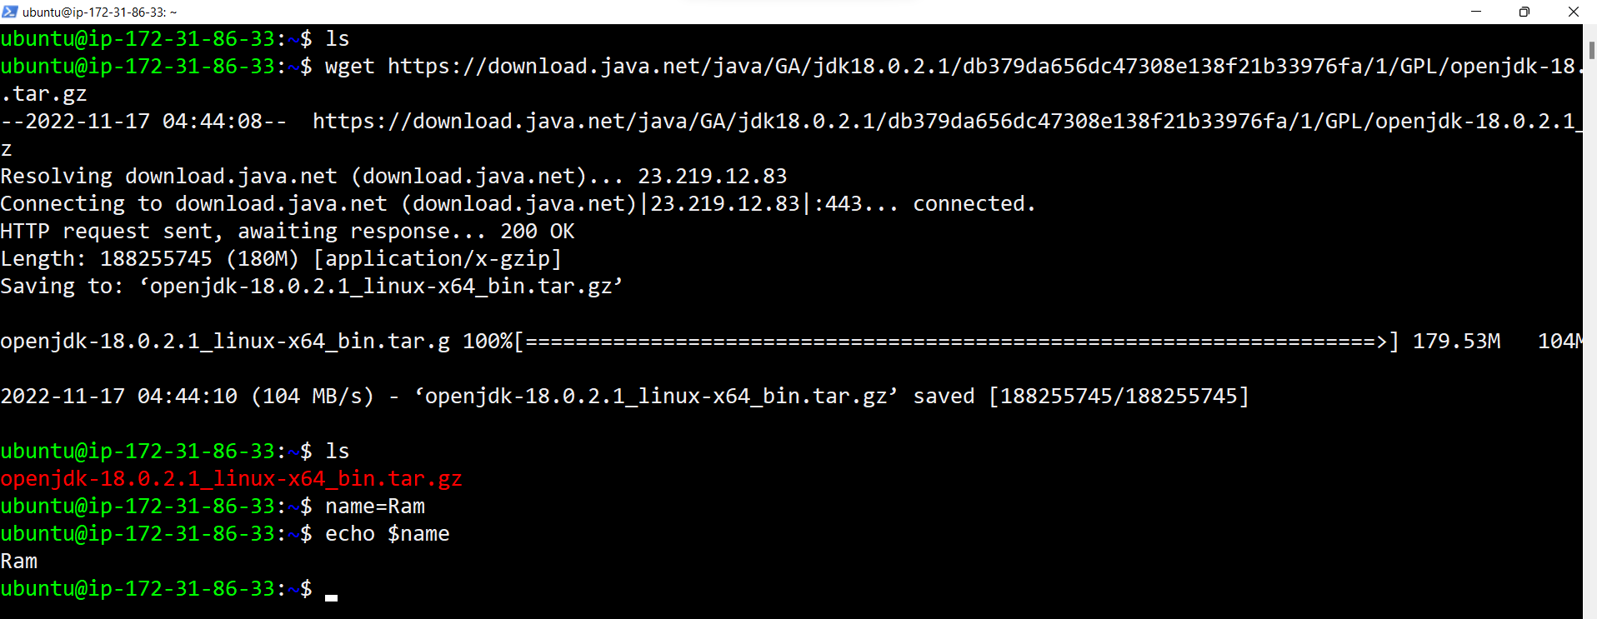

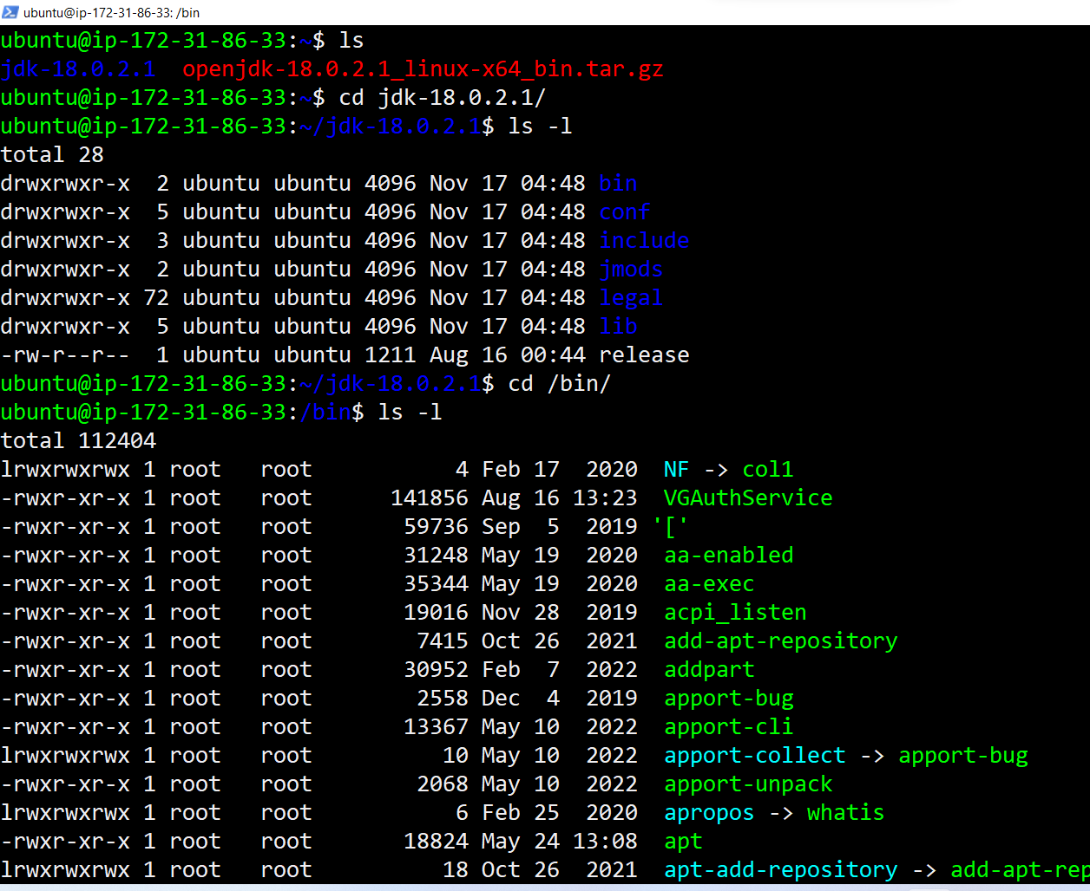

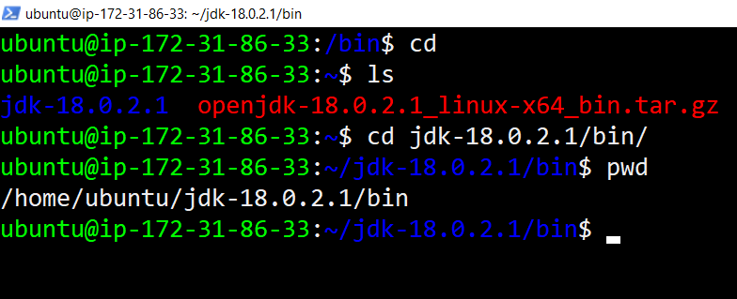

=> /home/ubuntu/jdk-18.0.2.1/bin

=> PATH=$PATH:$JAVA_HOME/home/ubuntu/jdk-18.0.2.1/bin

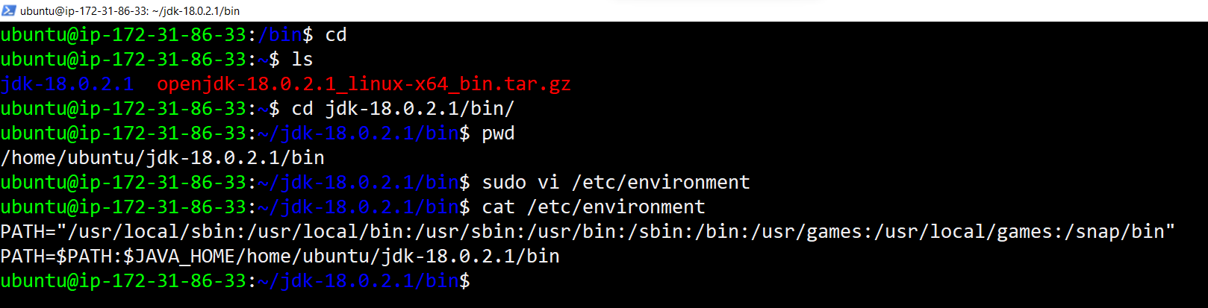

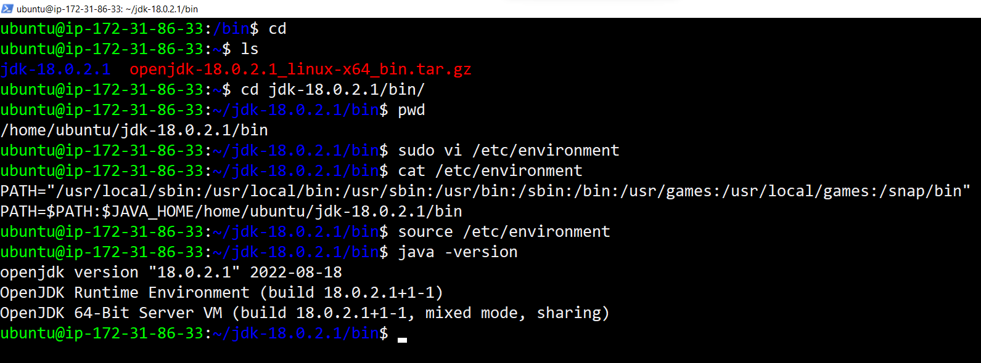

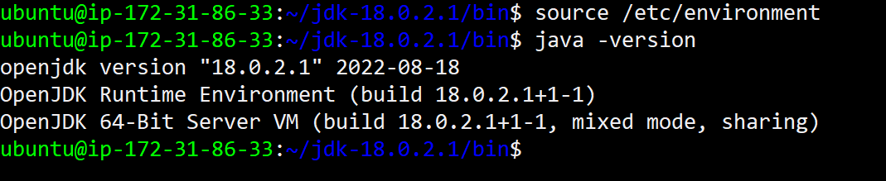

[ <https://download.java.net/java/GA/jdk18.0.2.1/db379da656dc47308e138f21b33976fa/1/GPL/openjdk-18.0.2.1_linux-x64_bin.tar.gz> ]

=> wget <https://download.java.net/java/GA/jdk18.0.2.1/db379da656dc47308e138f21b33976fa/1/GPL/openjdk-18.0.2.1_linux-x64_bin.tar.gz>

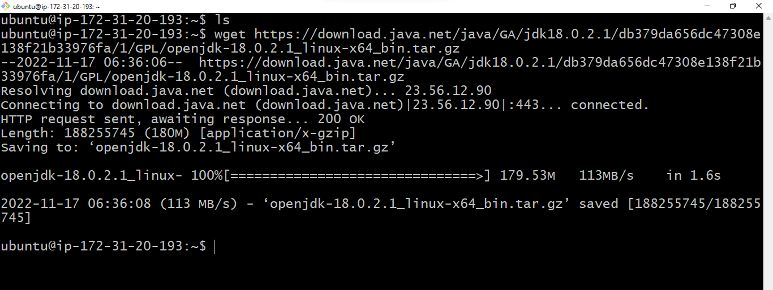

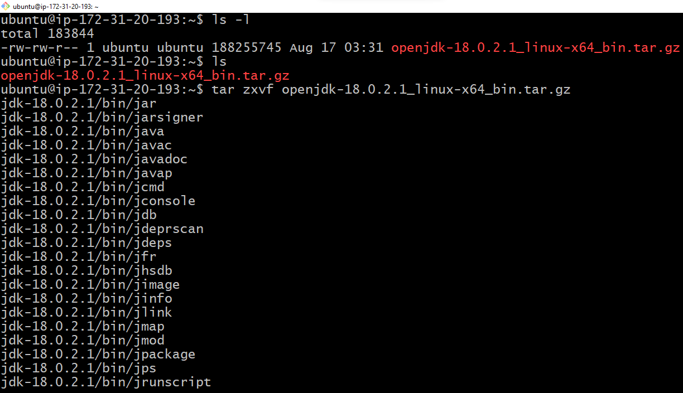

=> /home/ubuntu/jdk-18.0.2.1/bin

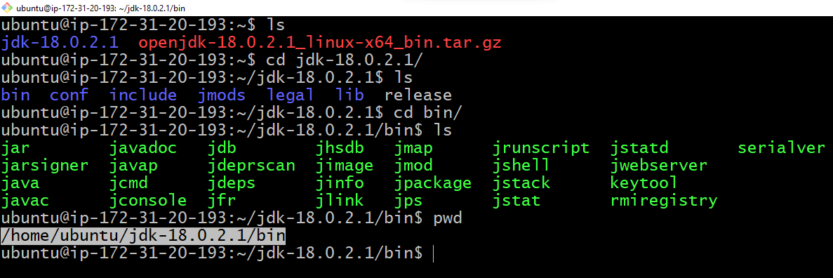

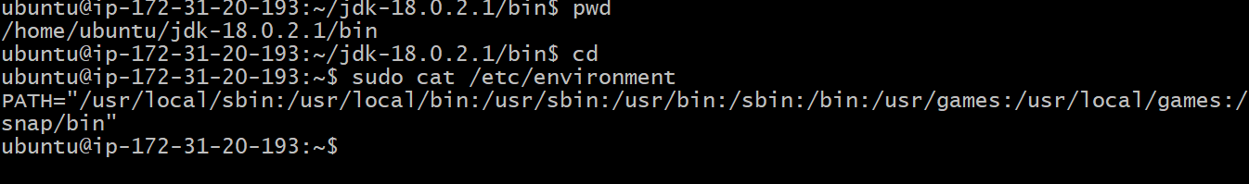

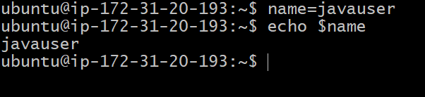

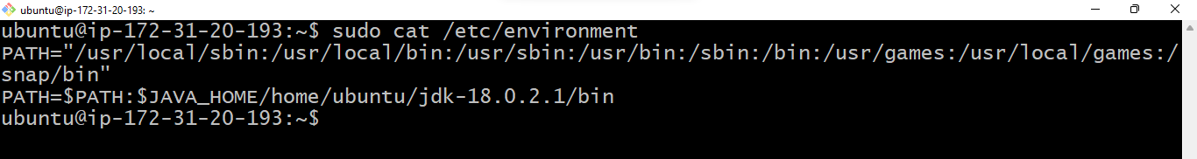

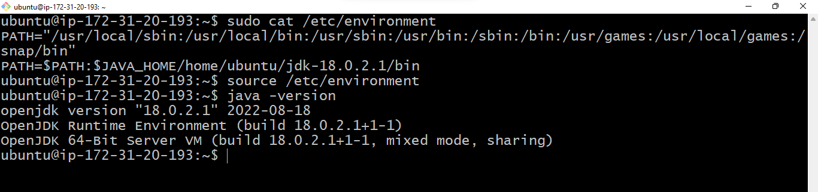

Another way

—-------------

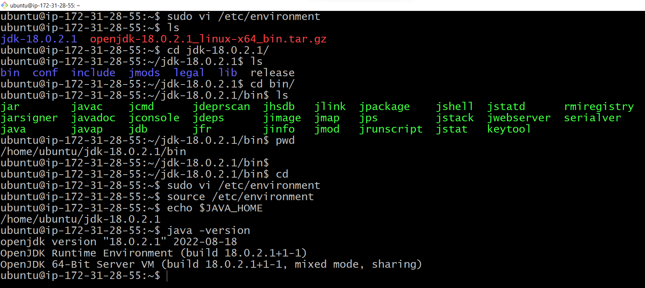



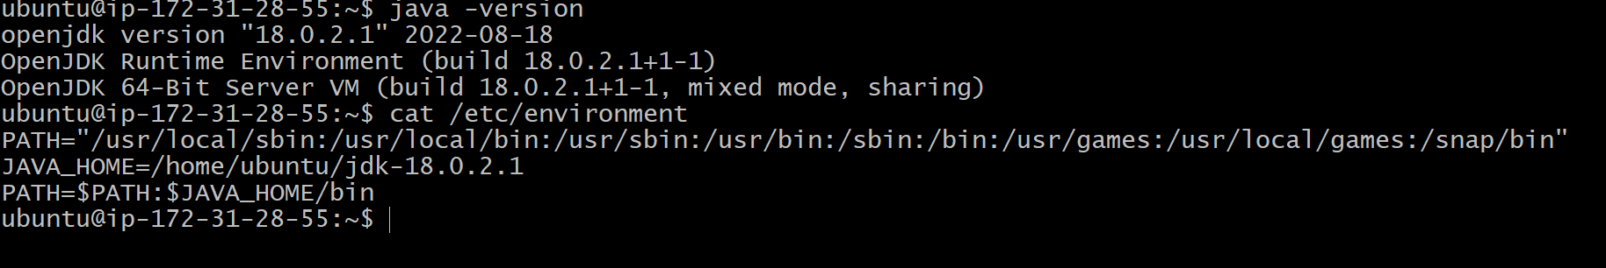

—-----------------------------------------------------------------------------------

<https://directdevops.blog/2020/07/28/linux-classroom-series-28-jul-2020/>

<https://www.elastic.co/guide/en/logstash/current/installing-logstash.html#package-repositories>

===============================================

YAML and JSON Basics 👍

—---------------------------

<https://www.cloudbees.com/blog/yaml-tutorial-everything-you-need-get-started>

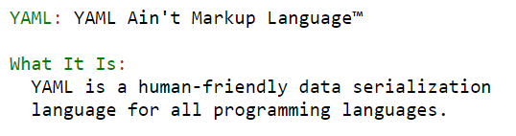

<https://www.tutorialspoint.com/yaml/yaml_basics.htm>

<https://www.w3schools.io/file/yaml-introduction/>

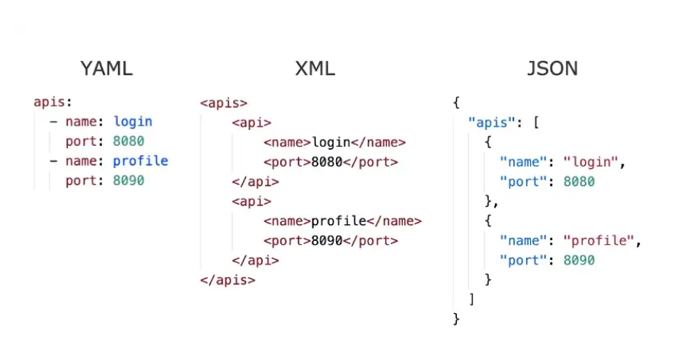

<https://www.tutorialspoint.com/yaml/yaml_indentation_and_separation.htm>

<https://levelup.gitconnected.com/yaml-tutorial-everything-you-need-to-know-in-5-mins-14f333a23ed1>

<https://www.json2yaml.com/>

<http://www.yamllint.com/>

